2.1 Functions and Relations (Review)

Relation
A relation is a set of ordered pairs.

The set of x-values of all the points
is called the domain of the relation,
and the set of y-values is called the range.

Example 1

x = y²
The domain is x 0
The range is “all real numbers”

More Examples

My own examples

When working with domain and range in any equation:
Not having a negative number inside an even root and,
Not having zero in the denominator

Example 2

y = 2 - 3 – x 3 – x = 0
the domain is 3 x, because an even root must be 0

the range is y 2 because it is 2 minus the positive value of 3 – x

More Examples

My own examples

Function – for every value of the domain (x-value), there is one and only one value for the
range (y-value)
(any x-value can only have one y-value

Example 3
a. (1, 3), (2, 5), (4, 7) is a function because each x- value has only one value for y
b. (1, 3), (1, -1), (4, 7) is not a function

More Examples

My own example

One-to-One Functions
Every one value of the domain is associated with one value of range and vice versa

Hierarchy of Relations,
of Functions, and relation

of One-to-One Functions function

one-to-one function

Example 4

x₁ y₁
x₂ y₂
x₃ y₃
x₁ y₁
x₂ y₂
x₃ y₃
x₁ y₁
x₂ y₂
x₃ y₃

Domain Range Domain Range Domain Range
A one-to-one function A function but not Not a function,
One-to-one. just a relation.
Both x₁ and x₂ go to y₁ x₁ goes to both y₁ and y₂

More Examples

My own examples

Line Tests for Functions

Vertical line test for functions:
An equation defines y as a function of x if and only if every vertical line in the coordinate plane intersects the graph of the equation only once.

Horizontal line test for one-to-one functions:
A function, y, is one-to-one function of X if and only if every horizontal line in the coordinate plane intersects the functions at most only once.

Example 5
State whether each of the following relations is the function, a one-to-one function, or neither.

A vertical line intersects the graph once, A vertical line intersects the graph once, A vertical line intersects the graph
a horizontal line intersects the graph once, a horizontal line intersects the graph more more than once, so this is not a
therefore, graph is a one-to-one function than once, therefore, graph is just a function
function
More Examples

My own examples

Example 6
Determine the domain and range of the following relations:
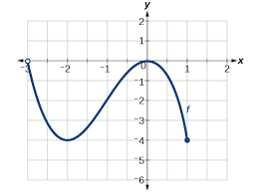
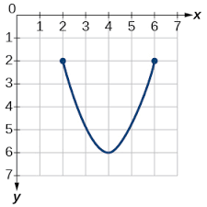

Domain: -2 x 3 Domain: 2 x 6 Domain: -3 x 1
Range: {-2, -1, 0, 1, 2} Range: -6 y -2 Range: -4 y 0

More Examples

My own examples

