3.4 Equations and Graphs of Polynomials Functions

|  |
| --- |
| Match each graph with an equation below. After you have matched the graphs. Try and use the words degree, quadrant, intercept, maximum/maxima, and minimum/minima. A. C.  B. D. |

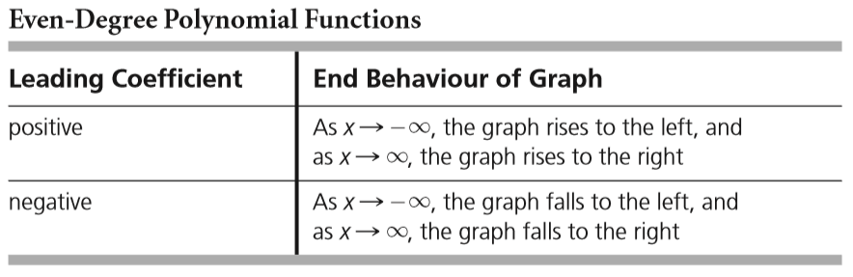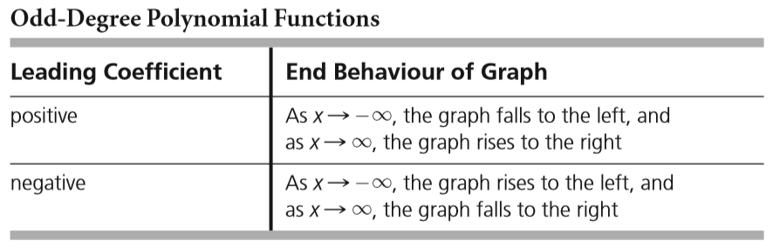

The shape of the graph of a function close to a zero depends on its multiplicity.



Multiplicity refers to how many times a root is repeated (see ex: 3, 3.3) once a polynomial is factored. The multiplicity affects the shape of the graph near the x-axis.

|  |  |  |  |
| --- | --- | --- | --- |
| Multiplicity = 1 | Multiplicity = 2 | Multiplicity = 3 | Multiplicity = 4 |

Ex: 1 Sketch the graph of the polynomial function $f\left(x\right)=-2x^{3}+6x-4$.

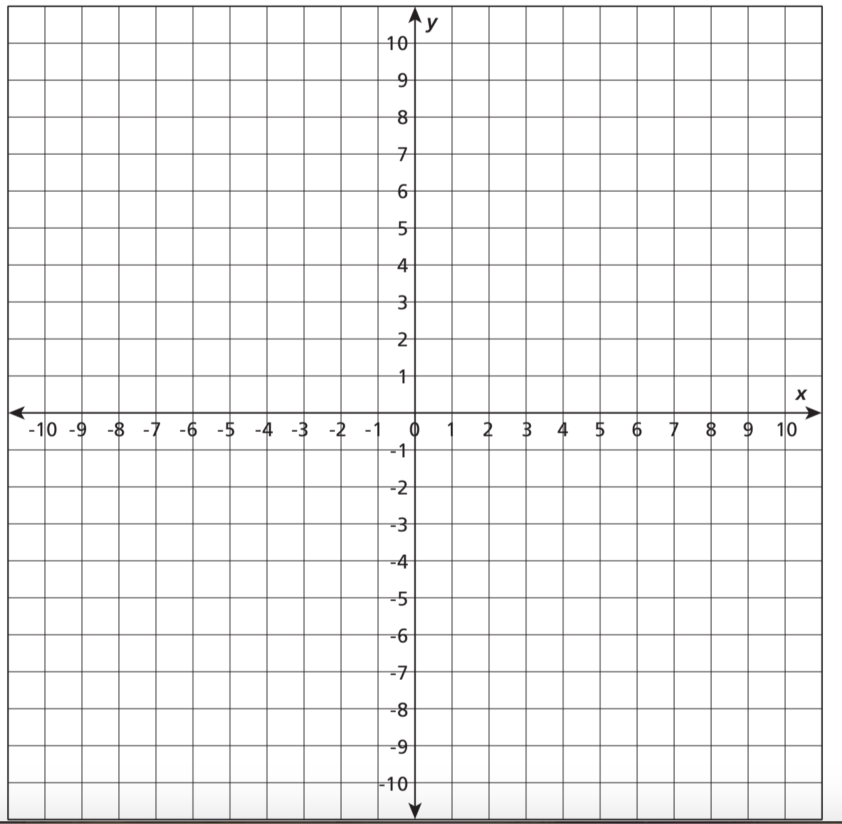

Ex: 3 Sketch the graph of the polynomial function $f\left(x\right)=x^{2}\left(x+2\right){\left(x-2\right)}^{3}$ using multiplicity.



Ex: 4 For the graph, below, of a polynomial function, determine

a) the least possible degree

b) the sign of the leading coefficient

c) the x-intercept(s) and the factors of the function.

d) the intervals where the function is positive and where it is negative.



Ex: 5 Find an equation for the following graph (same graph as above)



Desmos Constructing Polynomials