Name: _______________________________ Nov. 21, 2022
Mr. Formaran

Worksheet #1
WORD SEARCH

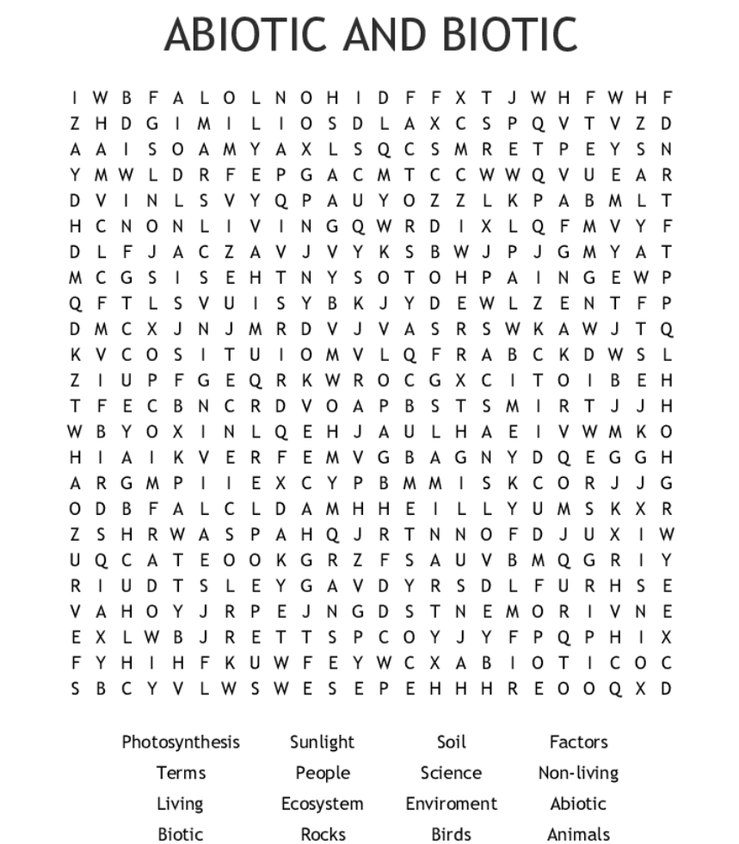

Name: _______________________________ Nov. 21, 2022
Mr. Formaran

Worksheet #2
Crossword Puzzle
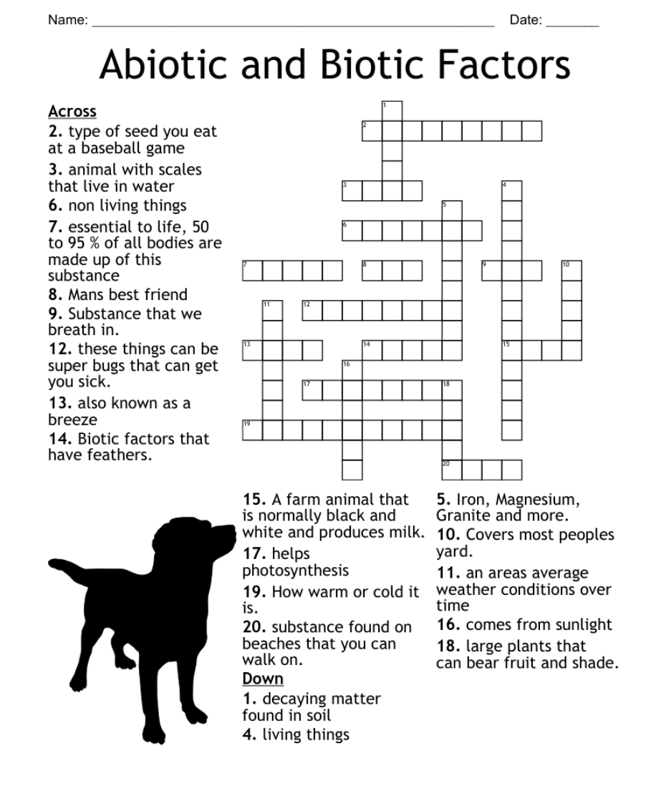

Name: _______________________________ Nov. 21, 2022
Mr. Formaran

Worksheet #3
Crossword Puzzle
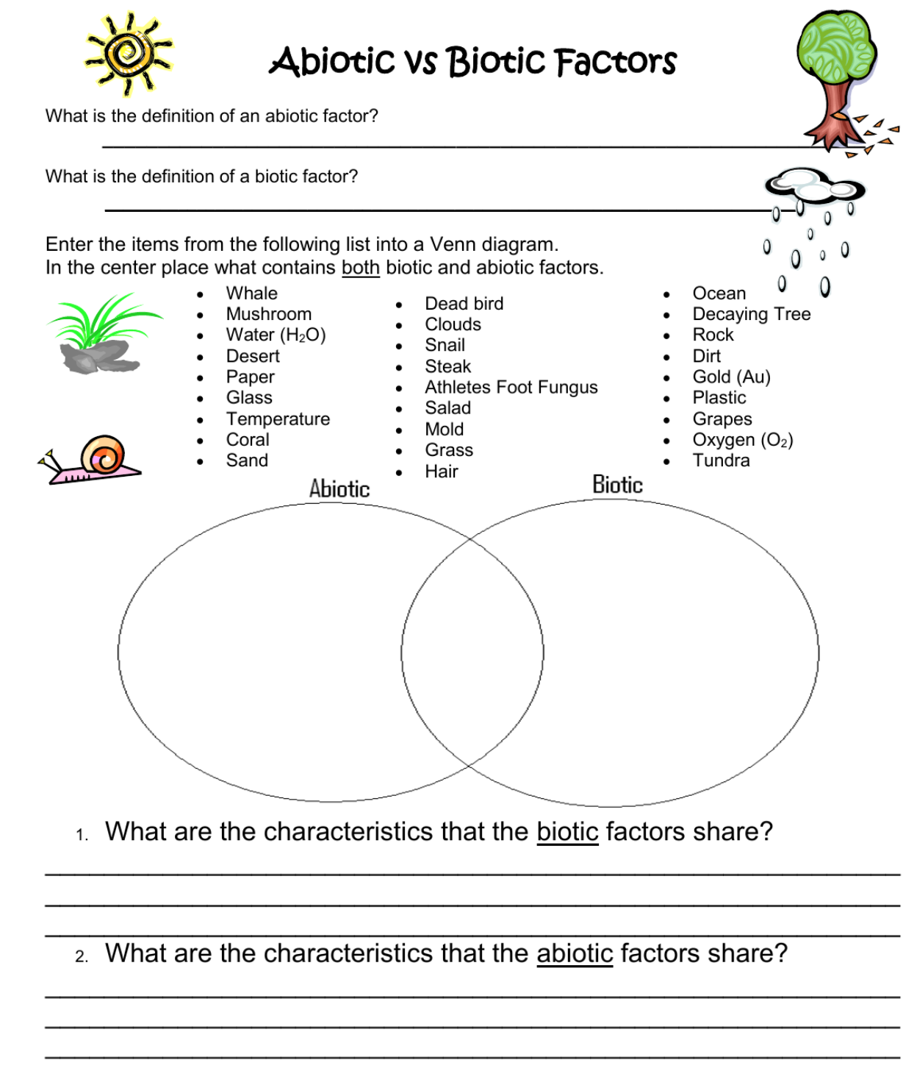

Name: _______________________________ Nov. 21, 2022
Mr. Formaran

Worksheet #4
Venn Diagram

Look around you and list at least 30 things you see in the proper category using Venn Diagram.

Biotic

Abiotic

Why did you have things in the intersection of biotic and abiotic?
_____________________________________________________________________________

