Name: _______________________________ Nov. __, 2022
Mr. Formaran

Worksheet #1
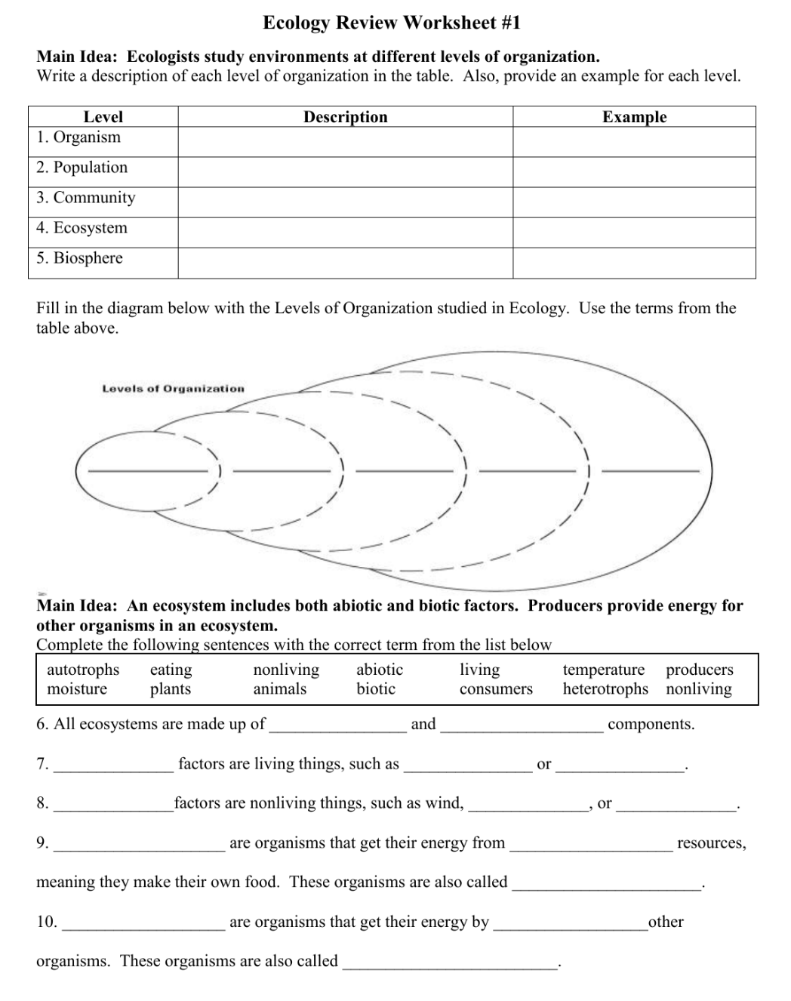

Name: _______________________________ Nov. __, 2022
Mr. Formaran

Worksheet #2

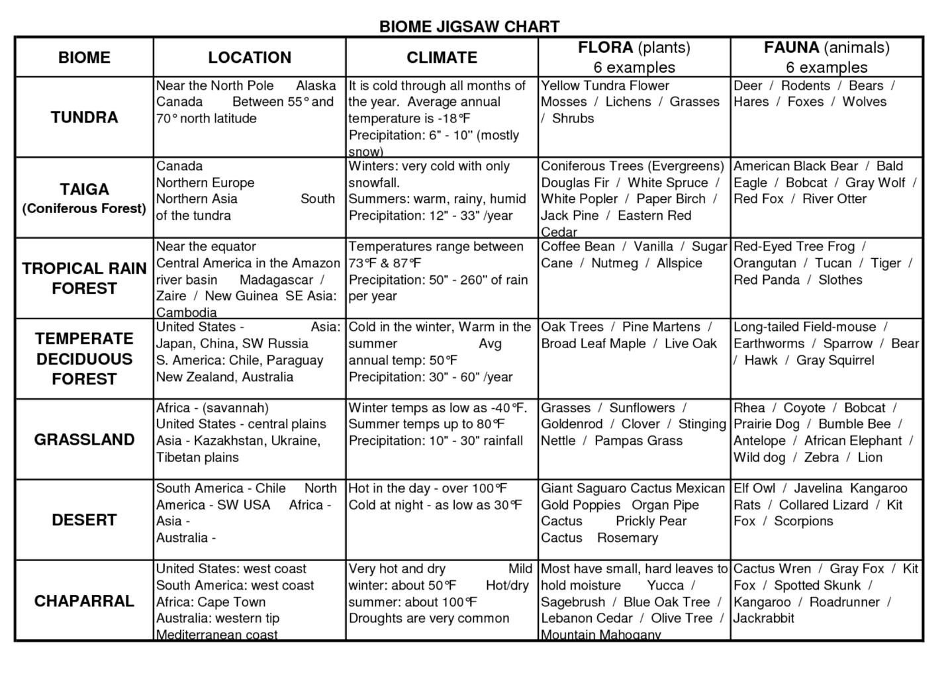

List at least 3 more countries for each kind of Biome
Tundra | Taiga | Tropical  Rain  Forest | Temperature  Deciduous  Forest | Grassland | Desert | Chaparral

Name: _______________________________ Nov. __, 2022
Mr. Formaran

Worksheet #3
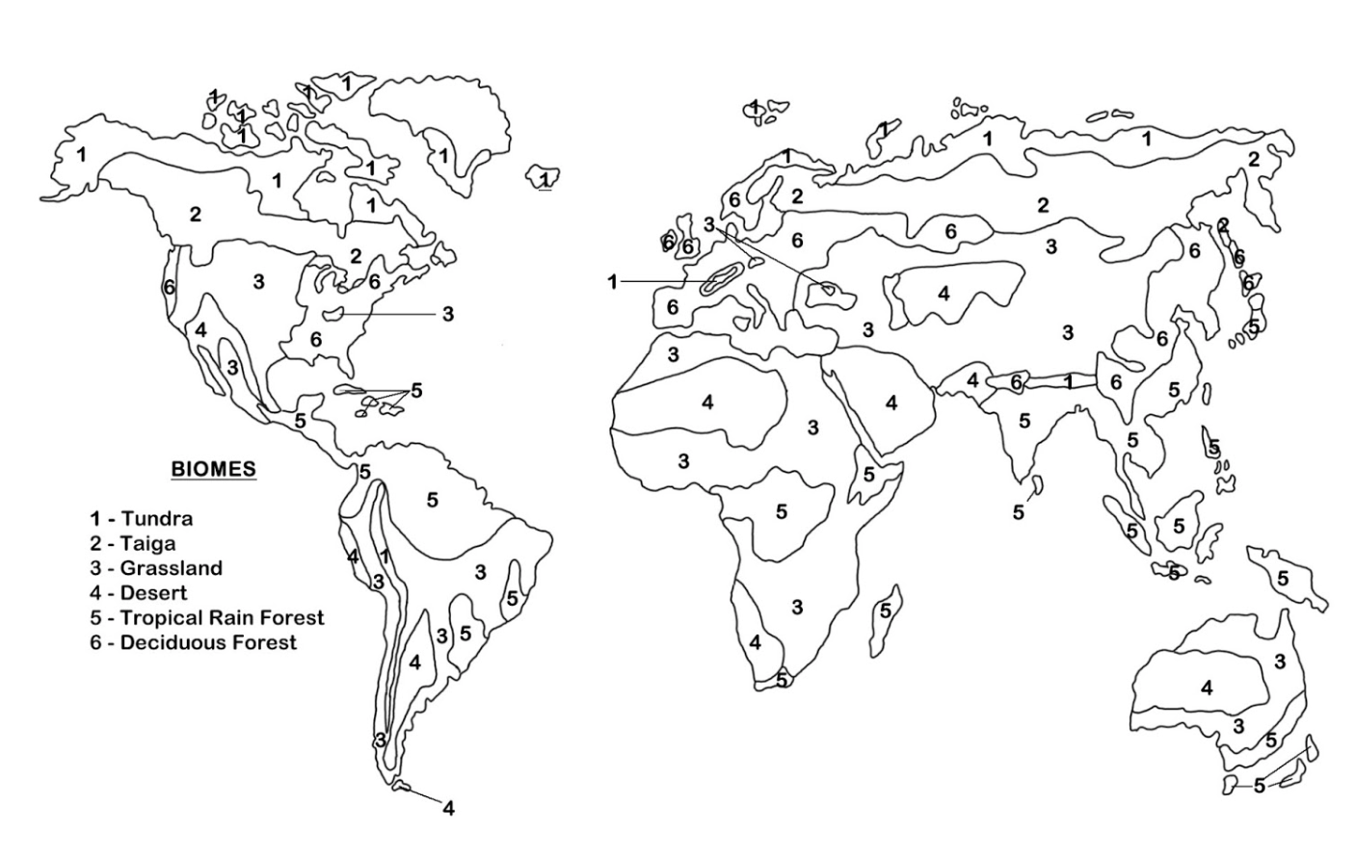
Color the map according to its color number

1 – Tundra (blue)
2 – Taiga (Red)
3 – Grassland (Yellow)
4 – Desert (Orange)
5 – Tropical Rain Forest (Yellow Green)
6 – Temperate Deciduous Forest (Green)

Name: _______________________________ Nov. __, 2022
Mr. Formaran

Worksheet #4
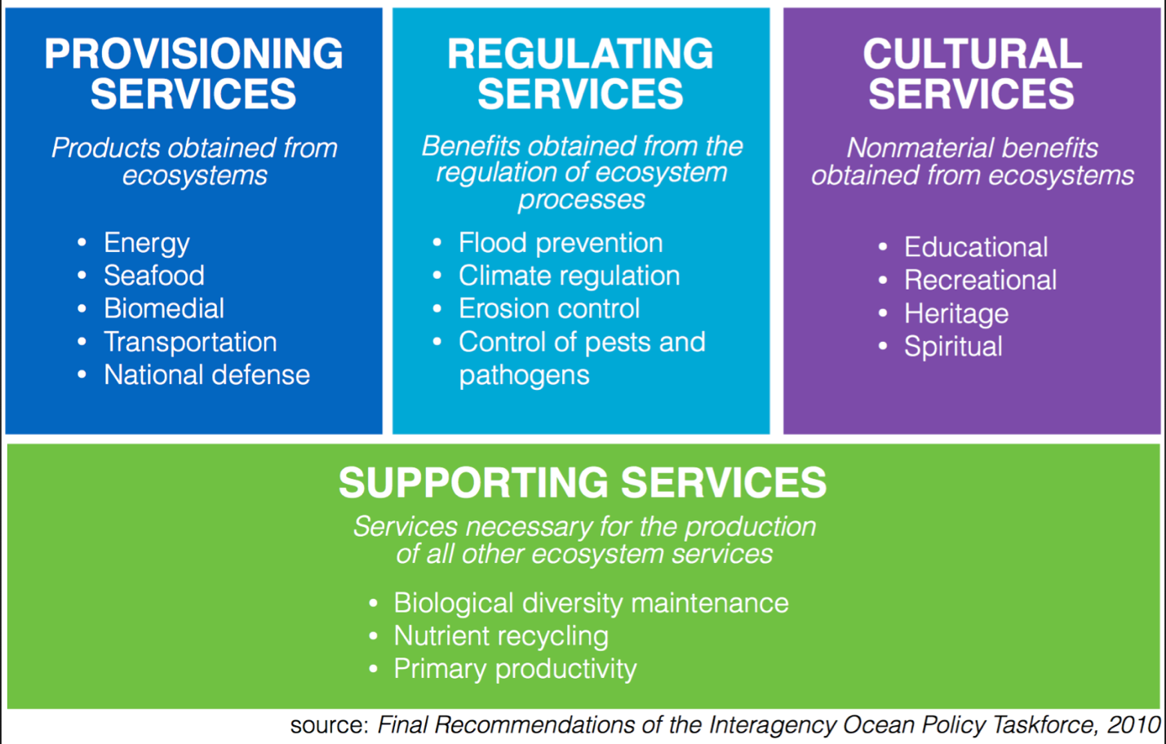

Give 5 examples for each Ecosystem Service
Provisioning | Regulating | Cultural | Supporting

Name: _______________________________ Nov. __, 2022
Mr. Formaran

Worksheet #5

Can you Spot Bias?

Paste/write at least two articles/news report on the same science topic. Can you determine if the articles or news reports are biased? If so, how do you know?. Read page 290 on our textbook, re-examine the articles and news report to see whether your answer has changed and why?

____________________________________________________________________________________
____________________________________________________________________________________
____________________________________________________________________________________
____________________________________________________________________________________

____________________________________________________________________________________
____________________________________________________________________________________
____________________________________________________________________________________
____________________________________________________________________________________

Name: _______________________________ Nov. __, 2022
Mr. Formaran

Research
Pages 294 – 295, Textbook

Effects of Artic Ice Cap Melting

Question
How does the melting of the Artic ice cap affect Earth’s spheres and sustainability?

Procedure
Part A
Research: Why the Artic ice cap is melting? (5 marks)
Summary:
________________________________________________________________________
________________________________________________________________________
________________________________________________________________________
________________________________________________________________________
________________________________________________________________________
________________________________________________________________________

Part B
Research: Effects of the melting of the Artic ice cap on the hydrosphere (2 marks)
Answer:
- ____________________________________________________________________
____________________________________________________________________
____________________________________________________________________

- ____________________________________________________________________
____________________________________________________________________
____________________________________________________________________
Summary: (5 marks)
________________________________________________________________________
________________________________________________________________________
________________________________________________________________________
________________________________________________________________________
________________________________________________________________________
________________________________________________________________________

Part C
Research: Effects of the melting of the Artic ice cap on the atmosphere (2 marks)
Answer:
- ____________________________________________________________________
____________________________________________________________________
____________________________________________________________________

- ____________________________________________________________________
____________________________________________________________________
____________________________________________________________________
Summary: (5 marks)
________________________________________________________________________
________________________________________________________________________
________________________________________________________________________
________________________________________________________________________
________________________________________________________________________
________________________________________________________________________

Part D
Research: Effects of the melting of the Artic ice cap on the biosphere (6 marks)
Answer:
- ____________________________________________________________________
____________________________________________________________________
____________________________________________________________________

- ____________________________________________________________________
____________________________________________________________________
____________________________________________________________________

- ____________________________________________________________________
____________________________________________________________________
____________________________________________________________________
Summary: (5 marks)
________________________________________________________________________
________________________________________________________________________
________________________________________________________________________
________________________________________________________________________
________________________________________________________________________
________________________________________________________________________

Part E
Research: Effects of the melting of the Artic ice cap on the geosphere (6 marks)
Answer:
- ____________________________________________________________________
____________________________________________________________________
____________________________________________________________________

- ____________________________________________________________________
____________________________________________________________________
____________________________________________________________________

- ____________________________________________________________________
____________________________________________________________________
____________________________________________________________________
Summary: (5 marks)
________________________________________________________________________
________________________________________________________________________
________________________________________________________________________
________________________________________________________________________
________________________________________________________________________
________________________________________________________________________

Analyze and Interpret (4 marks)
1. ____________________________________________________________________
____________________________________________________________________
____________________________________________________________________
____________________________________________________________________
2. ____________________________________________________________________
____________________________________________________________________
____________________________________________________________________
____________________________________________________________________
Conclude and Communicate (5 marks)
________________________________________________________________________
________________________________________________________________________
________________________________________________________________________
________________________________________________________________________
________________________________________________________________________
________________________________________________________________________
________________________________________________________________________
________________________________________________________________________

Content /50
Work Ethics /25
Understanding /25
TOTAL /100

