4.2 The Unit Circle

Unit Circle: A circle of radius 1 unit with centre at the origin on a graph.

If we think of a point P on the Unit Circle with coordinates (x,y) then you can draw a right triangle using the x axis and a vertical line to the point P. This triangle will have side lengths of x and y and a hypotenuse of 1.

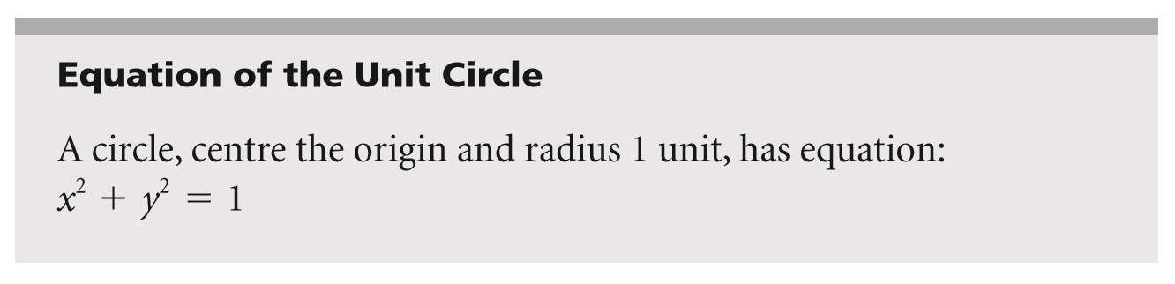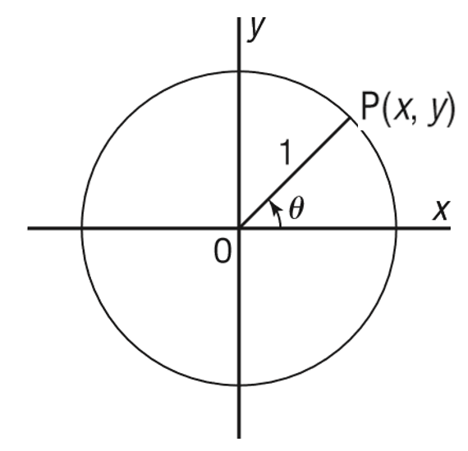

Using the unit circle we can create a function P that relates the angle θ in radians to the coordinates on the unit circle that make this angle.



For example P(π) = (-1,0)

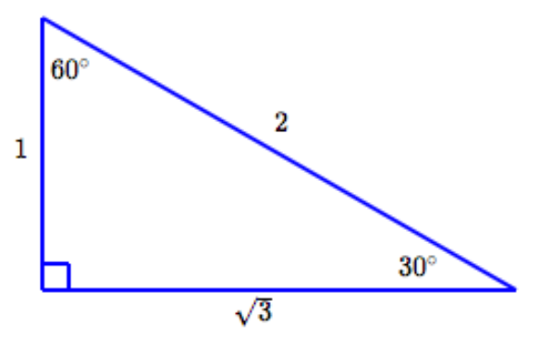Special Triangles with Exact Trigonometric Ratios:

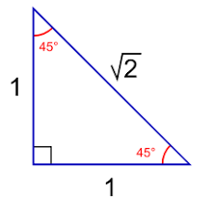

Ex: 1 Indicate all the multiples of $\frac{π}{3}$ for 0 $≤ θ ≤2π$

Ex: 2 Indicate all the multiples of $\frac{π}{2}$ for 0 $≤ θ ≤2π$

Ex: 3 Indicate all the multiples of $\frac{π}{6}$ for 0 $≤ θ ≤2π$

Ex: 4 Indicate all the multiples of $\frac{π}{4}$ for 0 $≤ θ ≤2π$

Ex: 5 Determine the coordinates for all points on the unit circle that satisfy the conditions given. Draw a diagram in each case.

a) The y-coordinate is $–\frac{1}{\sqrt{2}}$ and the point is in quadrant III.