5.1 Graphing Sine and Cosine Functions

**Periodic function:** a function that repeats itself over regular intervals of its domain. (the sine graph and cosine graph are periodic functions)

Period

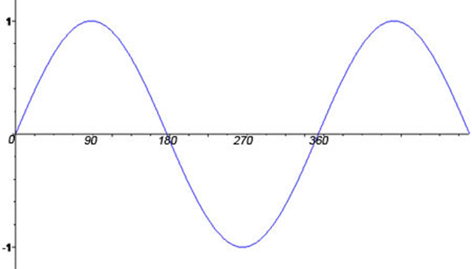

Amplitude

One Cycle

**Period**: The length (domain) of one cycle.

**Sinusoidal curve**: a curve that oscillates repeatedly up and down from a centre line.

(this centre line is sometimes called the sinusoidal axis.)

**Amplitude**: The maximum vertical distance of a sinusoidal curve above or below the central axis (center line or midline). This is represented by the vertical stretch factor.

NOTE: SPEND A LOT OF TIME CREATING SCALE WHEN GRAPHING

Ex 1: Sketch the graph of y = sin θ for 0˚ ≤ θ ≤ 360˚. Describe its characteristics below.

Create a table of values

|  |  |  |  |  |  |  |  |  |  |  |  |  |  |  |  |  |  |
| --- | --- | --- | --- | --- | --- | --- | --- | --- | --- | --- | --- | --- | --- | --- | --- | --- | --- |
| Degrees | 0 | 30 | 45 | 60 | 90 | 120 | 135 | 150 | 180 | 210 | 225 | 240 | 270 | 300 | 315 | 330 | 360 |
| Sin θ | 0 | $$\frac{1}{2}$$ | $$\frac{\sqrt{2}}{2}$$ | $$\frac{\sqrt{3}}{2}$$ | 1 | $$\frac{\sqrt{3}}{2}$$ | $$\frac{\sqrt{2}}{2}$$ | $$\frac{1}{2}$$ | 0 | $$-\frac{1}{2}$$ | $$-\frac{\sqrt{2}}{2}$$ | $$-\frac{\sqrt{3}}{2}$$ | -1 | $$-\frac{\sqrt{3}}{2}$$ | $$-\frac{\sqrt{2}}{2}$$ | $$-\frac{1}{2}$$ | 0 |



Domain: Range: Min: Max:

amplitude: period: y-intercept: $θ$-interepts:

Ex: 2 Sketch the graph of y = Cos θ for 0˚ ≤ θ ≤ 360˚. Describe its characteristics below.

Create a table of values

|  |  |  |  |  |  |  |  |  |  |  |  |  |  |  |  |  |  |
| --- | --- | --- | --- | --- | --- | --- | --- | --- | --- | --- | --- | --- | --- | --- | --- | --- | --- |
| Degrees | 0 | 30 | 45 | 60 | 90 | 120 | 135 | 150 | 180 | 210 | 225 | 240 | 270 | 300 | 315 | 330 | 360 |
| Cos θ |  |  |  |  |  |  |  |  |  |  |  |  |  |  |  |  |  |



Domain: Range: Min: Max:

amplitude: period: y-intercept: $θ$-interepts:

Ex 3: Vertical stretch and flip of a sine or cosine graph.

a) Using desmos, graph y = 3sin x, y = 0.5sin x, y = -2sin x, for 0 ≤ x ≤ 2π.

b) Compare each graph to the graph of y = sin x. Consider the period, amplitude, domain and range.

Ex: 4 Determine the amplitude of each function and graph it.  
a) $y=2\cos{x}$ b)

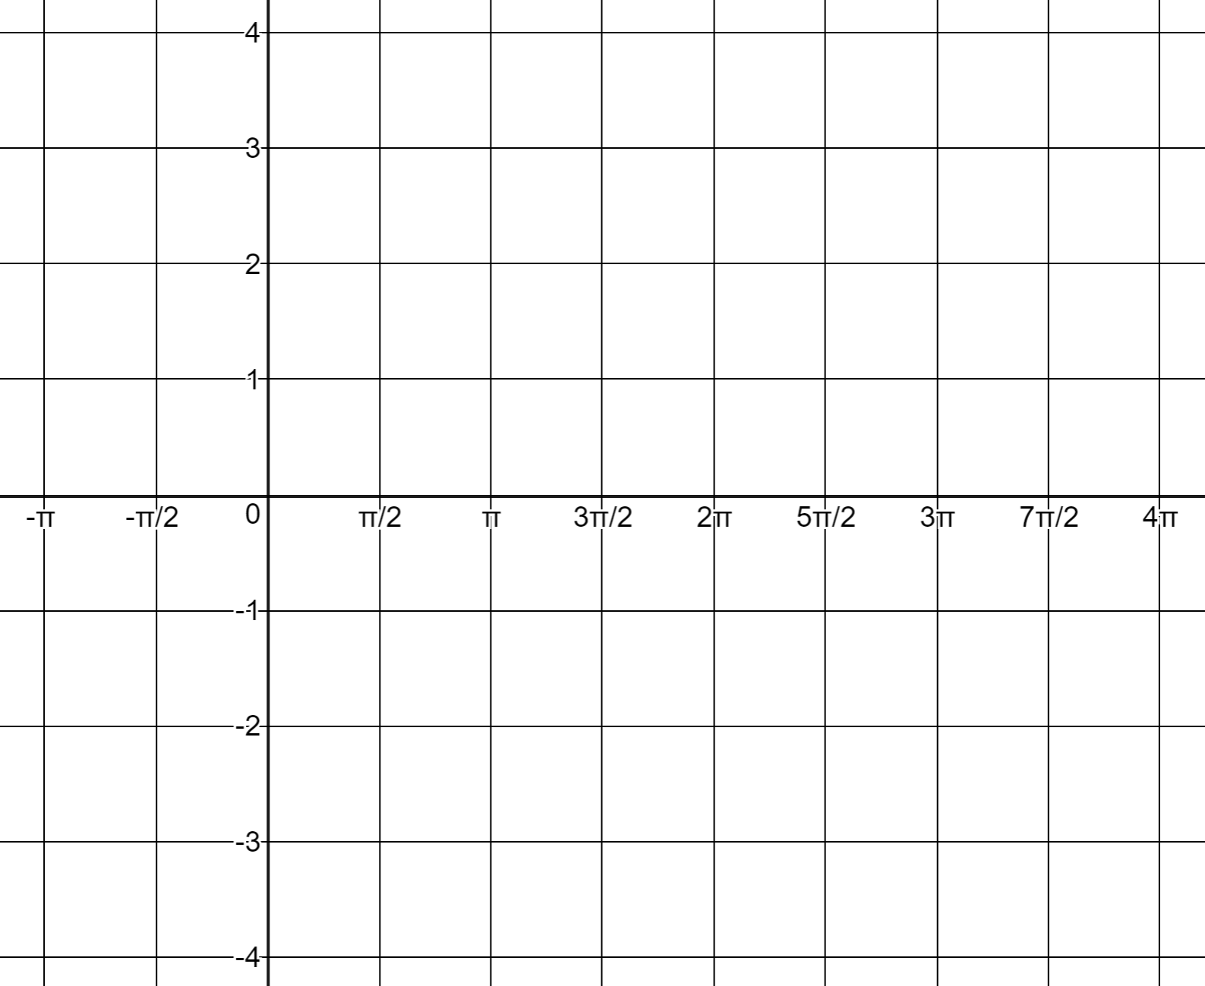

Ex: 5 Determine the period of each function and graph it.  
a) $y=\cos{2x}$ b) $y=$ sin ½ x



Ex: 6 Determine the phase shift for each function and graph it.  
a) $y=\sin\left(x+\frac{π}{2}\right)$ b) $y=$ cos (x - $\frac{π}{ 2})$

c) y = sin (x) + 2 d) y = cos (x) - 1  
