5.2 Transformations of Sinusoidal Functions

**Amplitude: $\left|a\right|$**

**Phase shift:**

Bx – c = 0 b(x - c)=0

X= $c, c>0 shift right$

$c<0 shift left$

**Period**: $\frac{2π}{b}$ Horizontal Stretch of 1/b

**Vertical Displacement**: d, d $>0, shift upward$

**y = a Sin b(x-c) + d**

Vertical Displacement

Phase shift

Horizontal Stretch

Vertical Stretch

d $<0, shift downward$

$$y=a\sin{b \left(x-c\right)+d}$$

Assume a $≠0, b>0$

**Vertical displacement**: The vertical shift of the graph of a periodic function.

**Phase shift**: The horizontal shift of the graph of a periodic function.

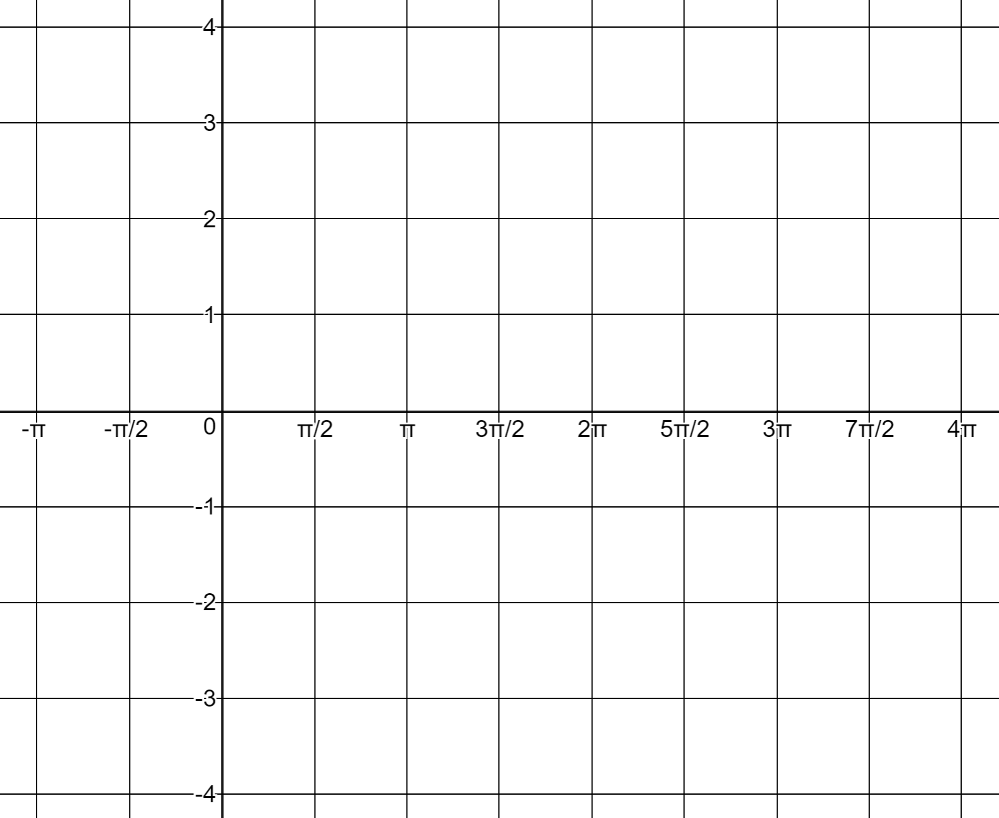Ex: 1 Identify the amplitude, period, horizontal shift, and midline for the function. Then graph it.

  
$$y=3\sin{\frac{1}{2}\left(x+\frac{π}{2}\right)-1}$$

Ex: 2 Identify the amplitude, period, starting position, and midline and then graph.

$$y=2\cos{2\left(x-π\right)+1}$$

Ex: 3 Identify the amplitude, period, horizontal shift, and midline and then write an equation in terms of sin(x).

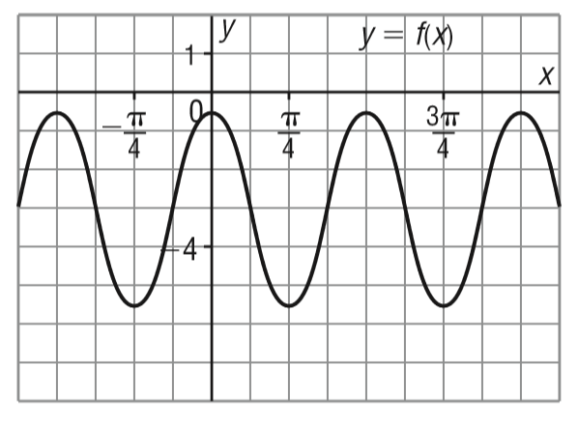

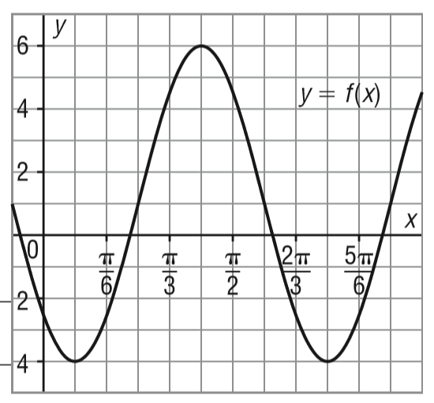Ex: 4 Identify the amplitude, period, horizontal shift, and midline and then write an equation in terms of sin(x).

DESMOS ACTIVITY: GRAPHING THE SINE FUNCTION

DESMOS MARBLESLIDES

Ex: 5 Sketch the graph of y=sin (θ-45˚) +2 for two cycles then fill in the table below



|  |  |  |  |  |
| --- | --- | --- | --- | --- |
| Vertical stretch factor | Horizontal stretch factor | Phase shift | Vertical displacement | Midline |
|  |  |  |  |  |

b) Sketch the graph of y = cos (θ + π) -1 for two cycles then fill in the table below



|  |  |  |  |  |
| --- | --- | --- | --- | --- |
| Vertical stretch factor | Horizontal stretch factor | Phase shift | Vertical displacement | Midline |
|  |  |  |  |  |

Ex: 6 Sketch the graph of the function

Y = 3 sin (2x - $\frac{2π}{3}$) + 1 over two cycles********* FACTOR OUT “B”



**Find the following**

Vertical displacement:

Amplitude:

Period:

Phase shift:

Domain:

Range:

|  |  |  |  |  |  |  |  |  |  |  |  |  |  |  |  |  |  |  |  |  |  |  |  |  |
| --- | --- | --- | --- | --- | --- | --- | --- | --- | --- | --- | --- | --- | --- | --- | --- | --- | --- | --- | --- | --- | --- | --- | --- | --- |
|  |  |  |  |  |  |  |  |  |  |  |  |  |  |  |  |  |  |  |  |  |  |  |  |  |
|  |  |  |  |  |  |  |  |  |  |  |  |  |  |  |  |  |  |  |  |  |  |  |  |  |
|  |  |  |  |  |  |  |  |  |  |  |  |  |  |  |  |  |  |  |  |  |  |  |  |  |
|  |  |  |  |  |  |  |  |  |  |  |  |  |  |  |  |  |  |  |  |  |  |  |  |  |
|  |  |  |  |  |  |  |  |  |  |  |  |  |  |  |  |  |  |  |  |  |  |  |  |  |
|  |  |  |  |  |  |  |  |  |  |  |  |  |  |  |  |  |  |  |  |  |  |  |  |  |
|  |  |  |  |  |  |  |  |  |  |  |  |  |  |  |  |  |  |  |  |  |  |  |  |  |
|  |  |  |  |  |  |  |  |  |  |  |  |  |  |  |  |  |  |  |  |  |  |  |  |  |