5.3 The Tangent Function
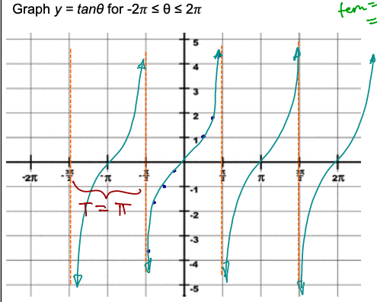
If x = cos$θ$ and y=sin$θ$ and tan$θ=\frac{y}{x}$
Then, tan$θ= \frac{sinθ}{cosθ}$
Tan is undefined for____________________________________
Domain_________________________________________
Range___________________________
The period of tan$θ$ is _______________
Tan $θ$ has no amplitude_____________________________

Ex: 1 Graph the function y= tan θ for 0 ≤ θ ≤ $2π$ . Describe its characteristics.
Degrees | 0 | $$\frac{π}{6}$$ | $$\frac{π}{4}$$ | $$\frac{π}{3}$$ | $$\frac{π}{2}$$ | $$\frac{2π}{3}$$ | $$\frac{3π}{4}$$ | $$\frac{5π}{6}$$ | π | $$\frac{7π}{6}$$ | $$\frac{5π}{4}$$ | $$\frac{4π}{3}$$ | $$\frac{3π}{2}$$ | $$\frac{5π}{3}$$ | $$\frac{7π}{4}$$ | $$\frac{11π}{6}$$ | $$2π$$
Tan θ

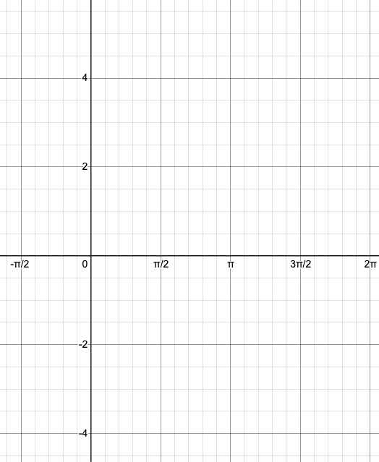

a) Is the graph continuous?

b) What is the amplitude?

c) Find the domain and range.

d) What is the period?

