Foundation of Mathematics and Pre-Calculus 10

Chapter 1

Real Numbers

Name: ___________________________________________ Mr. Formaran

1.1 Number Systems

Number: ____________________ Numeral: _____________________

Hindu—Arabic Number System Roman Numerals
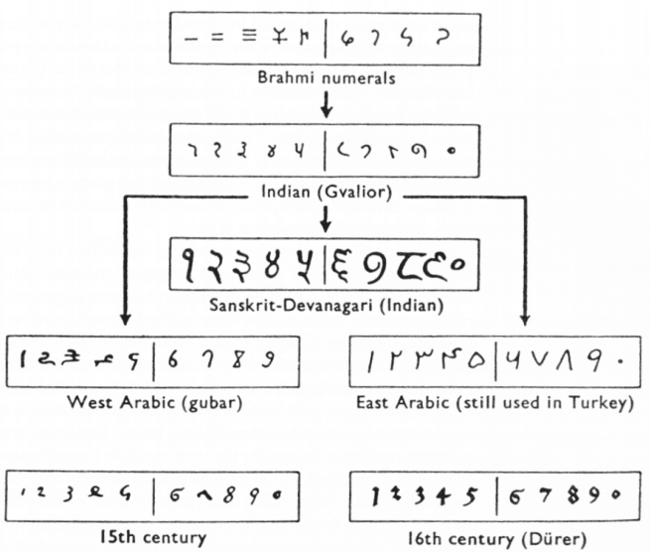
1 = ________
2 = ________
3 = ________
4 = ________
5 = ________
6 = ________
7 = ________
8 = ________
9 = ________
10 = ________
100 = ________
500 = ________
1000 = ________

Try these:

Numerals Brahmi Numerals Roman Numerals

______________ ________________ ______________
______________ ________________ ______________
______________ ________________ ______________

______________ ________________ ______________
______________ ________________ ______________
______________ ________________ ______________

Natural Numbers ( ) : ___________________________
Whole Numbers ( ) : ___________________________
Integers ( ) : ___________________________
Rational Numbers ( ) : ___________________________
Irrational Numbers ( ) : ___________________________
Real Numbers ( ) : ___________________________

Try these:

Numerals | Natural | Whole | Integers | Rational | Irrational | Real

1.2 Greatest Common Factor and Least Common Multiple

Review:

Divisibility Properties

By 2 | A whole number is divisible by 2 if its last digit is even number:  0, 2, 4, 6, 8.
Examples:

By 3 | A whole number is divisible by 3 if the sum of its digits are multiple of 3, or divisible by 3.
Examples:

By 4 | A whole number is divisible by 4 if the last two digits are multiple of 4 or divisible by 4.  A whole number is divisible by 4 if the last two digits are zeros.
Examples:

By 5 | A whole number is divisible by 5 if the last digit is 0 or 5.
Examples:

By 6 | A whole number is divisible by 6 if it is an even number that is multiple of 3, or divisible by 3.  A whole number is divisible by 6 if it is divisible by 2 and 3.
Examples:

By 9 | A whole number is divisible by 9 if the sum of its digit is multiple of 9, or divisible by 9.
Examples:

By 10 | A whole number is divisible by 10 if it ends in a 0.
Examples:

Try these:
Put a check mark for each set that the number is divisible;

Numerals | By 2 | By 3 | By 4 | By 5 | By 6 | By 9 | By 10

Prime Number : ____________________________________________

1 | 2 | 3 | 4 | 5 | 6 | 7 | 8 | 9 | 10
11 | 12 | 13 | 14 | 15 | 16 | 17 | 18 | 19 | 20
21 | 22 | 23 | 24 | 25 | 26 | 27 | 28 | 29 | 30
31 | 32 | 33 | 34 | 35 | 36 | 37 | 38 | 39 | 40
41 | 42 | 43 | 44 | 45 | 46 | 47 | 48 | 49 | 50
51 | 52 | 53 | 54 | 55 | 56 | 57 | 58 | 59 | 60
61 | 62 | 63 | 64 | 65 | 66 | 67 | 68 | 69 | 70
71 | 72 | 73 | 74 | 75 | 76 | 77 | 78 | 79 | 80
81 | 82 | 83 | 84 | 85 | 86 | 87 | 88 | 89 | 90
91 | 92 | 93 | 94 | 95 | 96 | 97 | 98 | 99 | 100

List of Prime Numbers Less Than 100
______________________________________________________________________________

Composite Number : ______________________________________________________
______________________________________________________
List of Composite Numbers Less Than 100
______________________________________________________________________________
______________________________________________________________________________
______________________________________________________________________________

Zero ( 0 ) : ____________________________________________________________
One ( 1 ) : ____________________________________________________________
Try these:
Put a check mark for each set that the numeral is;

Numeral | Prime | Composite |  | Numeral | Prime | Composite

Greatest Common Factor (GCF) : ________________________________________
Least Common Multiple (LCM) : ________________________________________

Finding the Greatest Common Factor (GCF) and Least Common Multiple (LCM)

Methods
Factor Tree | Inverse Division
1.

2.

Factor Tree | Inverse Division
3.

4.

Try these:
Finding the Greatest Common Factor (GCF) and Least Common Multiple (LCM)
Factor Tree | Inverse Division
1.3 Squares and Square Roots

Perfect Squares (a²) : _______________________________

_____ _____ _____ _____

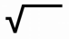
Square root ( a ) : _______________________________

Numeral | Squares | Computation | Square Numeral | Square root | Numeral
1 | 1² | 1 x 1 | 1 | 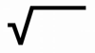  1 | 1
2 | 2² | 2 x 2 | 4 | 4 | 2
3 | 3² | 3 x 3 | 9 | 9 | 3
4
5
6
7
8
9
10
11
12
13
14
15
16
17
18
19
20

Finding Square Roots Without a Calculator or Table

Methods
Factor Tree | Inverse Division
Cubes and Cube Roots

Perfect Cubes (a³) : _______________________________

Cube root (^{3.} a ) : _______________________________

Numeral | Cubes | Computation | Cube Numeral | Cube root | Numeral
1 | 1³ | 1 x 1 x 1 | 1 | ³ 1 | 1
2 | 2³ | 2 x 2 x 2 | 8 | ³ 8 | 2
3 | 3³ | 3 x 3 x 3 | 27 | ³ 27 | 3
4
5
6
7
8
9
10

Numeral | 4th Power | Computation | Numeral to the 4th Power | Fourth root | Numeral
1 | 1⁴ | 1 x 1 x 1 x 1 | 1 | ^{4.} 1 | 1
2 | 2⁴ | 2 x 2 x 2 x 2 | 16 | ⁴ 16 | 2
3 | 3⁴ | 3 x 3 x 3 x 3 | 81 | ⁴ 81 | 3
4
5
6
7
8
9
10
Numeral | 5th Power | Computation | Numeral to the 5th Power | Fifth root | Numeral
1
2
3
4
5
6
7
8
9
10

Finding Roots Without a Calculator or Table

Methods
Factor Tree | Inverse Division

Try these:
Find Roots Without a Calculator or Table
Factor Tree | Inverse Division
1.4 Rational and Irrational Numbers

Review:
Rational: ______________________________________
Ex. ______________________________________

Irrational: ______________________________________
Ex. ______________________________________

Approximating Irrational Numbers.

Estimating the location of irrational numbers on number line.

Ordering irrational Numbers on number line.

1.5 Exponential Notation

Review: 3³ = _____________________________
(3a)² = _____________________________
(-a)³ = _____________________________
10w³ = _____________________________

Exponents of 0 and 1

a¹ = a, for any number of a.
any number raised to the power of 1 the answer is ____.
a⁰ = 1, for any non-zero number a.
any number raised to the power of 0 the answer is ____.

Examples:

_______________________________________________

_______________________________________________

_______________________________________________

_______________________________________________

Product Rule

a^{m} x a^{n} = a^{m + n} , a = 0
For any number a with exponents m and n
Multiplying expression by another expression with the same
base, the exponents will be added up.

Examples:
a² x a³ = (a¹ x a¹) (a¹ x a¹ x a¹) = a¹⁺¹⁺¹⁺¹⁺¹ = a⁵

_______________________________________________

_______________________________________________

_______________________________________________

_______________________________________________

Quotient Rule

a^{m}
= a^{m – n} , a = 0
a^{n}
For any number a with exponents m and n
Dividing expression by another expression with the same base,
the exponents will be subtracted.

Examples:
= = a⁴
a⁹ a x a x a x a x a x a x a x a x a
a⁵ a x a x a x a x a

_______________________________________________

_______________________________________________

_______________________________________________

_______________________________________________
Power Rule

(a^{m})^{n} = a^{(m)(n)}
For any number a with exponents m and n

Examples:
(4³)⁴ = 4⁽³⁾⁽⁴⁾ = 4²⁰

_______________________________________________

_______________________________________________

_______________________________________________

_______________________________________________

A Product to a Power Rule

(ab)^{n} = a^{n} x b^{n}
For any numbers a and b with exponent n

Examples:
(3a)² = 3² x a² = 9a²

_______________________________________________

_______________________________________________

_______________________________________________

_______________________________________________

A Fraction to a Power Rule

a ^{n} a^{n}
=
b b^{n}
For any numbers a and b, b = 0, with exponent n

Examples:
=
=
3 ² 3² 9
b b² b²

_______________________________________________

_______________________________________________

_______________________________________________

_______________________________________________

Negative Exponent Rule

1
a^{-n} =
a^{n}
For any number a, a = 0, with exponent n

Examples:
1
8
1
2³
2⁻³ = =

_______________________________________________

_______________________________________________

_______________________________________________

_______________________________________________
Changing from Negative to Positive Exponents Rule

a^{-m} a^{n} a ^{-m} b ^{m}
= and =
b^{-n} b^{m} b a
For any numbers a and b, b = 0, with exponent n

Examples:
=
=
2⁻² 3³ 27
3⁻³ 2² 4
=
=
4 ⁻² 5² 25
5 4² 16

_______________________________________________

_______________________________________________

_______________________________________________

_______________________________________________

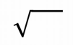
Rational Exponent Rule (a^{1/n})
a^{1/n} = ^{n} a¹
For any non-negative real number a, and any positive integer n.

Examples:
x^{1/2} = x

_______________________________________________

_______________________________________________

_______________________________________________

_______________________________________________

Rational Exponent Rule (a^{m/n})
^{m}
^{n}
a = ^{n} a^{m}
For any non-negative real number a, and any positive integer n.

Examples:
⁶
²
³
²
³
²
4 = (2²) = 2⁽²⁾⁽ ⁾ = 2 2³ = 8

_______________________________________________

_______________________________________________

_______________________________________________

_______________________________________________

1.6 Irrational Numbers

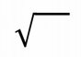
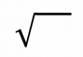
The Product Rule for Square Roots
For any real numbers A and B : A x B = A x B

Examples:
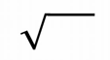  Method 1 | Method 2 | 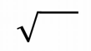  Method 3 | Method 4
72 | 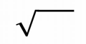  72 | 72 | 72
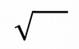
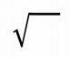
An expression such as 2 7 is called a mixed root,
and an expression 28 is called an entire root.

Examples:
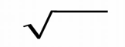
9 3 = 9² x 3 or 9 x 9 x 3
= 81 x 3
= 243

_______________________________________________

_______________________________________________

_______________________________________________

_______________________________________________

