Pre-calculus 10

Chapter 3

Relations and Functions

Name: ___________________________________________ Mr. Formaran

3.1 Relations

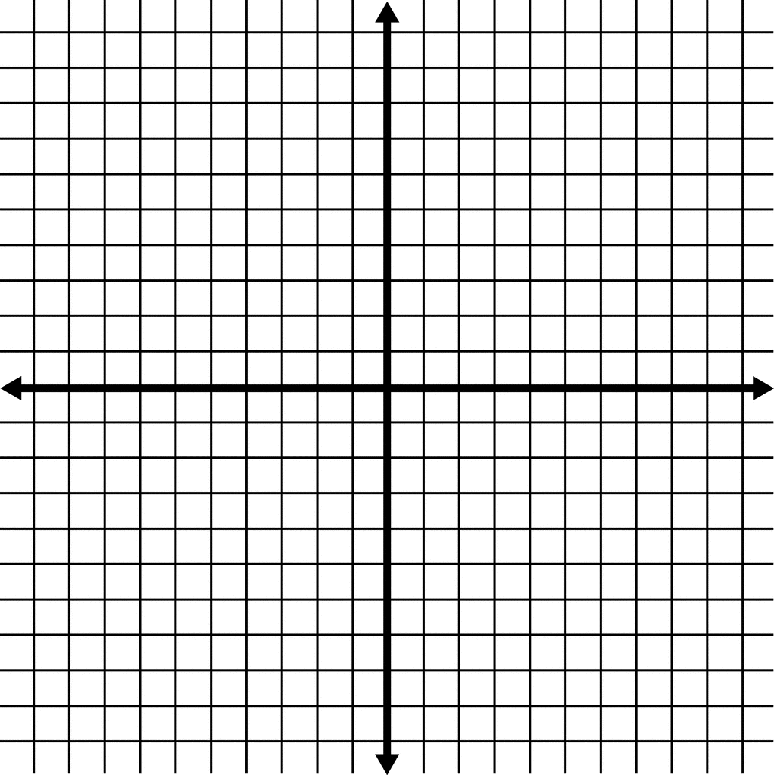
Coordinate System
c
 | x | y
a
b
c
d
e

a
e

 | x | y
 | 2 | 4
 | -3 | -3
 | -4 | 2
 | -5 | 0
 | 0 | -5
b
d

Relations are sets of ordered pairs (x , y)
X-value is the ____________ of the relation. X is independent variable
Y-value is the ____________ of the relation. Y is dependent variable

Relation can be represented as
Ordered Pairs | Mapping Notation
(1,2), (2,3), (-2,-1), (-3,-4) | 1 2  2 3  -2 -1  -3 -4
Table | Graph
x | y
1 | 2
2 | 3
-2 | -1
-3 | -4

My Own Examples

Ordered Pairs | Mapping Notation
Table | Graph
x | y

Example 1

Determine the domain and range of the ordered pairs.

A = { (1,2), (-3,5), (4, -2) } B = { (-3,4), (1,0), (0,2), (3,2) }

Domain of A: __________________ Domain of B: __________________
Range of A: __________________ Range of B: __________________

C = { (-2,1), (1,0), (3,3), (1,4) } D = { (-3,-1), (-3,3), (2,3), (4,0) }

Domain of A: __________________ Domain of B: __________________
Range of A: __________________ Range of B: __________________

My Own Examples

______________________________ ______________________________

Domain of __: __________________ Domain of __: __________________
Range of __: __________________ Range of __: __________________

Example 2 My Own Examples

Domain: _________________ Domain: _________________ Domain: ________________
Range: __________________ Range: __________________ Range: _________________
p

Example 3 My Own Examples

Domain: _________________ Domain: _________________ Domain: ________________
Range: __________________ Range: __________________ Range: _________________

Example 4 My Own Examples

Domain: _________________ Domain: _________________ Domain: ________________
Range: __________________ Range: __________________ Range: _________________

Example 5 My Own Examples

Domain: _________________ Domain: _________________ Domain: ________________
Range: __________________ Range: __________________ Range: _________________

Example 6 My Own Examples

Domain: _________________ Domain: _________________ Domain: ________________
Range: __________________ Range: __________________ Range: _________________

Example 7 My Own Examples

Domain: _________________ Domain: _________________ Domain: ________________
Range: __________________ Range: __________________ Range: _________________

Example 8 My Own Examples

Domain: _________________ Domain: _________________ Domain: ________________
Range: __________________ Range: __________________ Range: _________________

Example 9 My Own Examples

Domain: _________________ Domain: _________________ Domain: ________________
Range: __________________ Range: __________________ Range: _________________

Example 10 My Own Examples

Domain: _________________ Domain: _________________ Domain: ________________
Range: __________________ Range: __________________ Range: _________________

3.2 Functions

For every value of the domain (x-value), there is one, and only one, value for the range (y-value)

Hierarchy of Relations of Functions and of One-to-One Functions

Relation Function One-to-one Function

Example

Domain Range Domain Range Domain Range
(Input) (Output) (Input) (Output) (Input) (Output)

A one-to-one function A function, Not a function,
but not one-to-one. just a relation,
________________ _________________

My Own Examples

Domain Range Domain Range Domain Range
(Input) (Output) (Input) (Output) (Input) (Output)

A one-to-one function A function, Not a function,
but not one-to-one. just a relation,
________________ _________________

Example 1

Given ordered pairs: _________________________________________________________

When x is ____, the value of y is ____.
____ ____
____ ____
____ ____

My Own Example

Given ordered pairs: _________________________________________________________

When x is ____, the value of y is ____.
____ ____
____ ____
____ ____

Vertical Line Test for Function

An equation defines y as a function of x if and only if every vertical line in the coordinate plane intersects the graph of the equation once.

Horizontal Line Test for One-to-One functions

A function y is one-to-one function of x if and only if every horizontal line in the coordinate plane
intersects the function at most only once

Example 2

State whether each of the following relations is a function, one-to-one function or neither.

____________________ ____________________ ___________________
____________________ ____________________ ___________________
____________________ ____________________ ___________________

My Own Examples

State whether each of the following relations is a function, one-to-one function or neither.

____________________ ____________________ ___________________
____________________ ____________________ ___________________
____________________ ____________________ ___________________

Function Notation y = x² or f(x) = x²

Example 3

a. Let f(x) = x² + 1. Evaluate the function as an ordered pairs.

a. f(2) b. f(-3) c. f(a + 1)

b. Let f(x) = _____________. Evaluate the function as an ordered pairs.

a. f(2) b. f(-3) c. f(a + 1)

My Own Examples

Let f(x) = _______________. Evaluate the function as an ordered pairs.

a. f(2) b. f(-3) c. f(a + 1)

3.3 Linear Equations

An expression is a collection of numbers, variables, and operation signs

Examples My Own Examples

a. a.

b. b.

c. c.

d. d.

An equation is a mathematical statement that two expressions are equal.

Examples My Own Examples

a. a.

b. b.

c. c.

d. d.

A linear equation is any equation of the form Ax + By = C, where A, B and C are constants and x and y are variables. All linear equations are functions except a vertical line.

Examples My Own Examples

a. a.

b. b.

c. c.

d. d.

Graphing Linear Equations of the Type Ax + Bx = C

Example 1

A. Graph 3x + 2y = 6

Method 1 Solve for they y-value
x | y

Method 2
x | y

B. Graph ________________

Method 1 Solve for they y-value
x | y

Method 2
x | y

My Own Example
Graph ________________

Method 1 Solve for they y-value
x | y

Method 2
x | y

Graphing Linear Equations of the Type y = mx + b

Example 2
2
3
A. Graph y = - x + 4

Method 1 Solve for they y-value
x | y

Method 2
x | y

B. Graph __________________

Method 1 Solve for they y-value
x | y

Method 2
x | y

My Own Example
Graph ________________

Method 1 Solve for they y-value
x | y

Method 2
x | y

3.4 Non-Linear Equations

Example 1
Is x = y² a function?

Solution:
x | y

The graph is ______________________________________________________

Example 2
Is y = x² – 1 a function?

Solution:
x | y

The graph is ______________________________________________________

Example 3
Is y = x² + y² = 9 a function?

Solution:
x | y

The graph is ______________________________________________________

Example 4
Is y = 2^{x} a function?

Solution:
x | y

The graph is ______________________________________________________

Example 5
1
x
Is y = a function?

Solution:
x | y

The graph is ______________________________________________________

My Own Examples
Is y = ___________ a function?

Solution:
x | y

The graph is ______________________________________________________

My Own Examples
Is y = ___________ a function?

Solution:
x | y

The graph is ______________________________________________________

My Own Examples
Is y = ___________ a function?

Solution:
x | y

The graph is ______________________________________________________

