Pre-Calculus Mathematics 10

Chapter 8 Test

Name: __________________________________________ Date: _________
Mr. Formaran

Fill in the blanks. (8 marks)
(two decimal places) (one decimal place)
1. sin 35⁰ = __________ 5. sin⁻¹ 0.3929 = ________
2. cos 61⁰ = __________ 6. cos⁻¹ 0.9182 = ________
3. tan 90⁰ = __________ 7. tan⁻¹ 0.1078 = ________
4. cos 89.3⁰ = _________ 8. tan⁻¹ 2.2222 = ________

Solve for the following triangles. Show your solutions (6 marks)

1. a = b = c =
12
33⁰
c
a
b

2. a = b = c =

b
c
75 cm

40 cm
a

Solve for the unknown variable. Show your solutions. (4 marks)

75⁰
110 m
190 m
a

65⁰

Find the exact value of each expressions (10 marks)

Set A

2
sin30⁰ cos60⁰
4 sin²45⁰
5
sin45⁰
cos45⁰
1. 2. 3.

Set B

sin²45⁰ tan²45⁰
cos² 45⁰
2
cos60⁰
4. - 4 5.

Word Problems. (15 marks)
Draw the triangle with its proper label and show your solutions

1. When the angle of elevation of the sun is 30 degrees, a flagpole casts a shadow that is 12 feet long. In feet, how tall is the flagpole?

2. A ladder that is 120 feet long is resting against the side of a house at an angle of 65 degrees. In feet, how far up the side of the house does the ladder reach?

3. From the top of a lighthouse that sits 100 meters above the sea, the angle of depression of a boat is 20º. How far from the boat is the top of the lighthouse?

When the angle of elevation of the sun is 32 degrees, a flagpole casts a shadow that is 10 feet long. In feet, how tall is the flagpole?

Explanation:
You can draw the following right triangle from the information given by the question.
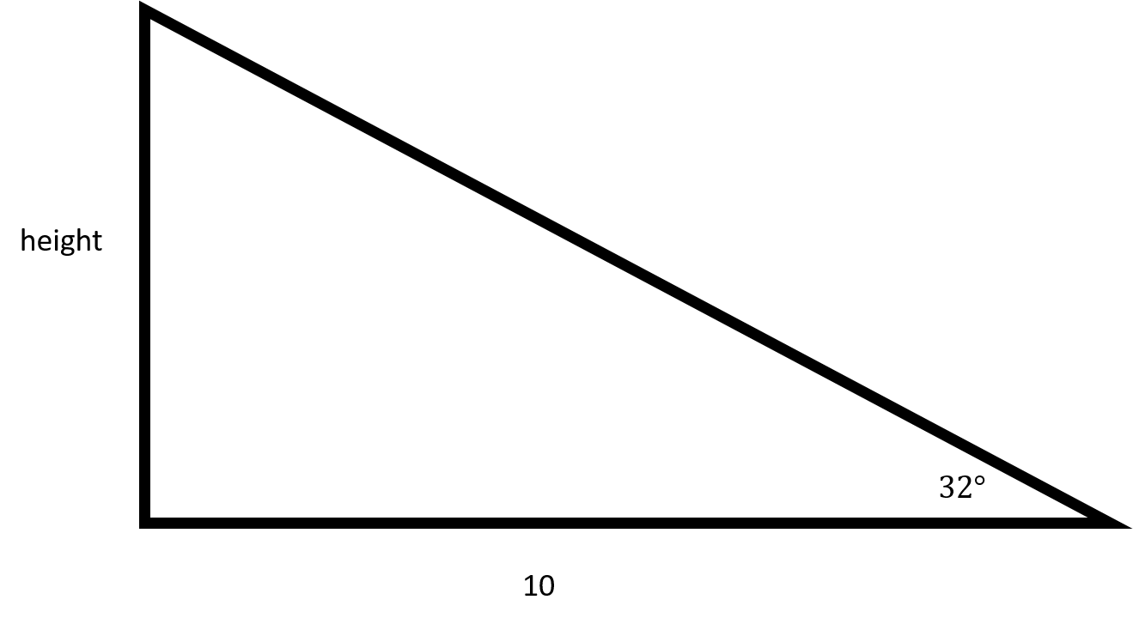
In order to find the height of the flagpole, you will need to use tangent.
tan32=height10
height=6.25
Make sure to round to 2 places after the decimal.
The flagpole is 6.25 feet tall.

A ladder that is 125 feet long is resting against the side of a house at an angle of 70 degrees. In feet, how far up the side of the house does the ladder reach?
Explanation:
You can draw the following right triangle from the information given in the question:
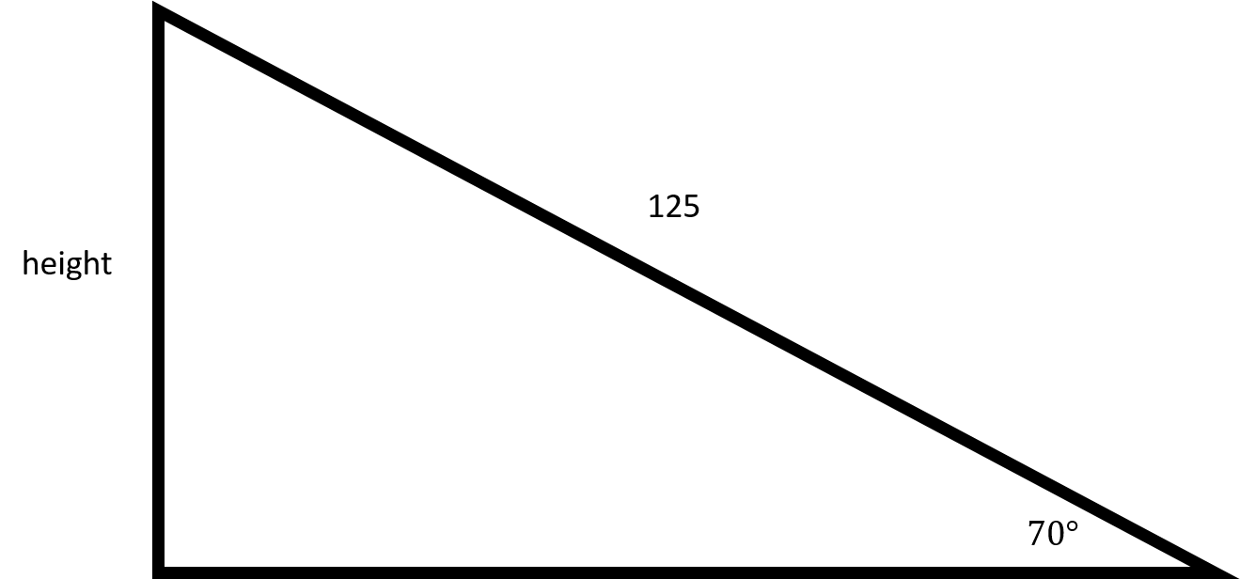
In order to find out how far up the ladder goes, you will need to use sine.
sin70=height125
height=117.46

From the top of a lighthouse that sits 105 meters above the sea, the angle of depression of a boat is 19º. How far from the boat is the top of the lighthouse?
Explanation:
To solve this problem, we need to create a diagram, but in order to create that diagram, we need to understand the vocabulary that is being used in this question. The following diagram clarifies the difference between an angle of depression (an angle that looks downward; relevant to our problem) and the angle of elevation (an angle that looks upward; relevant to other problems, but not this specific one.) Imagine that the top of the blue altitude line is the top of the lighthouse, the green line labelled GroundHorizon is sea level, and point B is where the boat is.
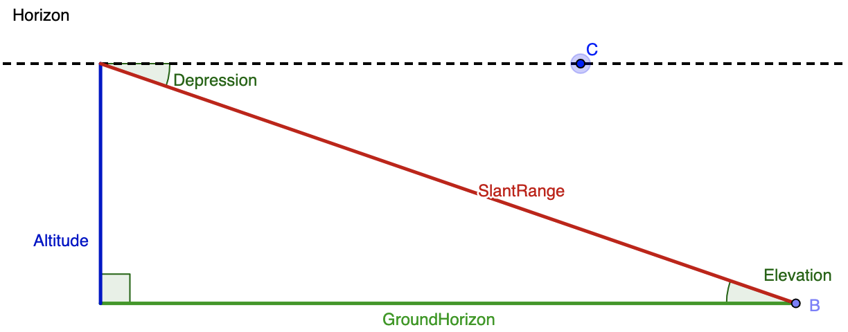
Merging together the given info and this diagram, we know that the angle of depression is 19º and and the altitude (blue line) is 105 meters. While the blue line is drawn on the left hand side in the diagram, we can assume is it is the same as the right hand side. Next, we need to think of the trig function that relates the given angle, the given side, and the side we want to solve for. The altitude or blue line is opposite the known angle, and we want to find the distance between the boat (point B) and the top of the lighthouse. That means that we want to determine the length of the hypotenuse, or red line labelled SlantRange. The sine function relates opposite and hypotenuse, so we'll use that here. We get:
sin19∘=105d (where d is the distance between the top of the lighthouse and the boat)
d=105sin19∘
d=105.33 (using a calculator in degree mode and rounding to two digits, we get that sin19∘=.33)
d=318.18 meters

