Pre-Calculus Mathematics 12

Level
Mark
%
Total
/20

/8

/6

/6

Chapter 3 Test

Name: __________________________________________ Date: _________
Mr. Formaran

True or False 12 marks
__________1. End behaviours: The tendency of the (y values) of a function as
the value of x tends toward $± ∞$
__________2. y = x³ + 2x² – x – 5 has an odd degree.

__________3. A function with even degree has end behaviour 2 1

__________4. y = x³ + 2x² – x – 5 has 1 – 5 possible x-intercepts

__________5. 3x + 6 divided by 3 = x + 2

__________6. x² + 5x + 6 divided by x + 3 = x + 2

__________7. x² – x + 2 divided by x -2 will have a zero remainder

__________8. x + 1 is a factor of x² – 1

__________9. Synthetic division can be used to find the factors of a function.

_________10. In a factor (x + 3), the value of a will be -3.

_________11. Quadratic function always has end behaviour 2 1

_________12. If 0 divided by 1 is 0, then, 1 divided by 0 is 0.

Section 3.1 8 marks

Fill in the blanks
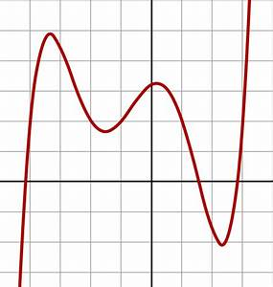
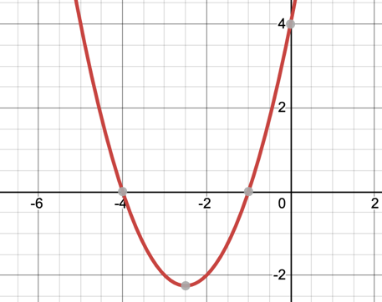
End Behaviours
Degree | (+) | (-)
Odd (1)
Even (2)
Odd (3)
Even (4)
Odd (5)
End behaviours: ______________ End behaviours: _______________
Domain: _________ Domain: ___________
Range: __________ Range: ____________
Number of possible x-int: _______ Number of possible x-int: _______

Identify the characteristics of the graph of each polynomial function. 8 marks
Function | Degree/(odd or even) | Possible  x-intercept | Max/Min | y-intercept
x⁴ + 3x³ - x² - 4 | ______ / ______ | _____ | ____ | ____
-3x³ – x – 3 | ______ / ______ | _____ | ____ | ____
x⁵ – 3x - 1 | ______ / ______ | _____ | ____ | ____
-x² – 1 | ______ / ______ | _____ | ____ | ____

Section 3.2 6 marks

Divide by synthetic division

x³ + 9x² + 23x + 15; x + 5 x³ – x² – 14x + 25; x – 3

8x⁵ + 32x⁴ + 5x + 20; x + 4

Section 3.3 6 marks

Solve the following using the factor theorem and rational theorem as necessary.

x³ – x² – 14x + 25 x⁴ – x³ + 14x² – 16x – 32

25x³ + 150x² + 131 x + 30

