Pre-Calculus 12

Level
Mark
Total

Chapter 7A Test

Name: _______________________________________________ Nov. 23, 2021
Mr. Formaran

Section 7.1 and 7.2

Simplify

5a⁸b³c⁵ ⁰
15a⁶b⁵c⁴
(3a⁸)³
9a⁶
1. 4. _______
25x⁸y³z⁵
15x⁶y⁵z⁴

² 100a⁸b⁴c¹⁰
³ 125a¹²b³c¹⁵
18a⁸b³
27a⁻⁸b⁻³
2. 5.

2⁰
0²
-3a^{-x}b^{y -1}
9a^{x}b^{-y}
3. 6.

Graph y=2(2)^{x-2} + 2, state the parameters, describe the transformations.
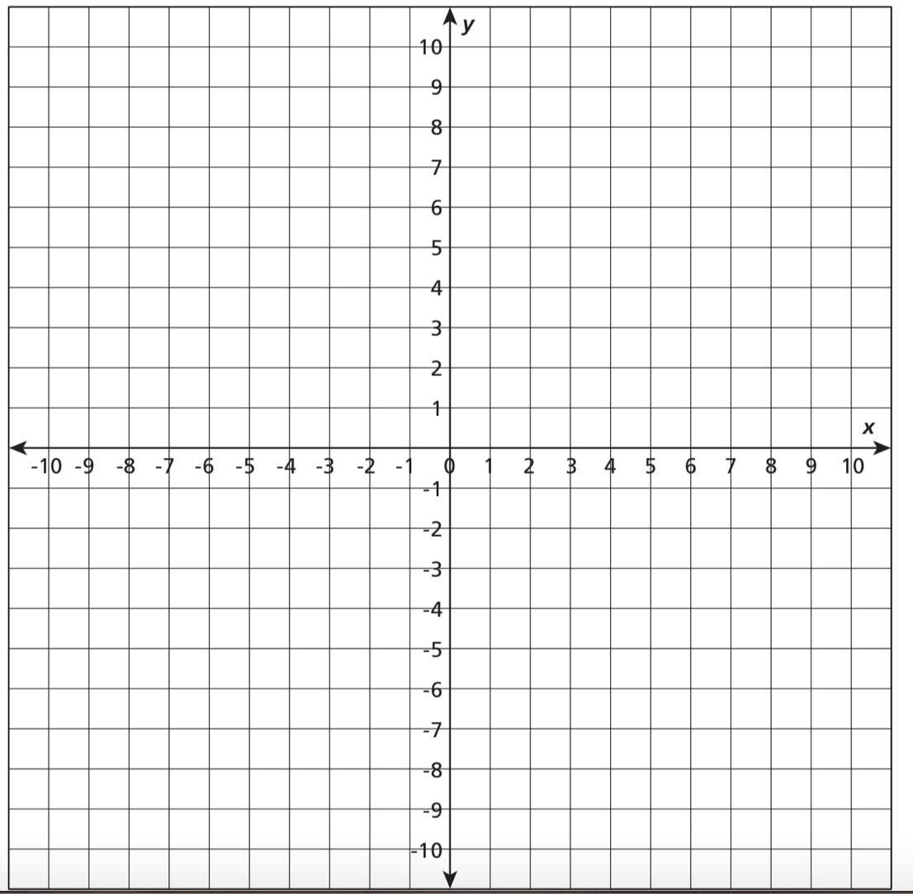
x | y
-2
-1
0
1
2

Parameter | a= | b= | h= | k=
transformation

Domain | Range | Horizontal asymptote | X-intercept | y-intercept

Section 7.3

Solve the following

1. 2^{2x} = 2⁶ 3. ^{m} 7² = 49

2. 3^{3x – 2} = 81^{1/4} 4. 32^{2a – 2} = ⁴ 16ª

