Name: ______________________________________________ Nov 29, 2022
Mr. Formaran

4.2 Concept 1

Greenhouse Gases and Effect
https://www.youtube.com/watch?v=SN5-DnOHQmE

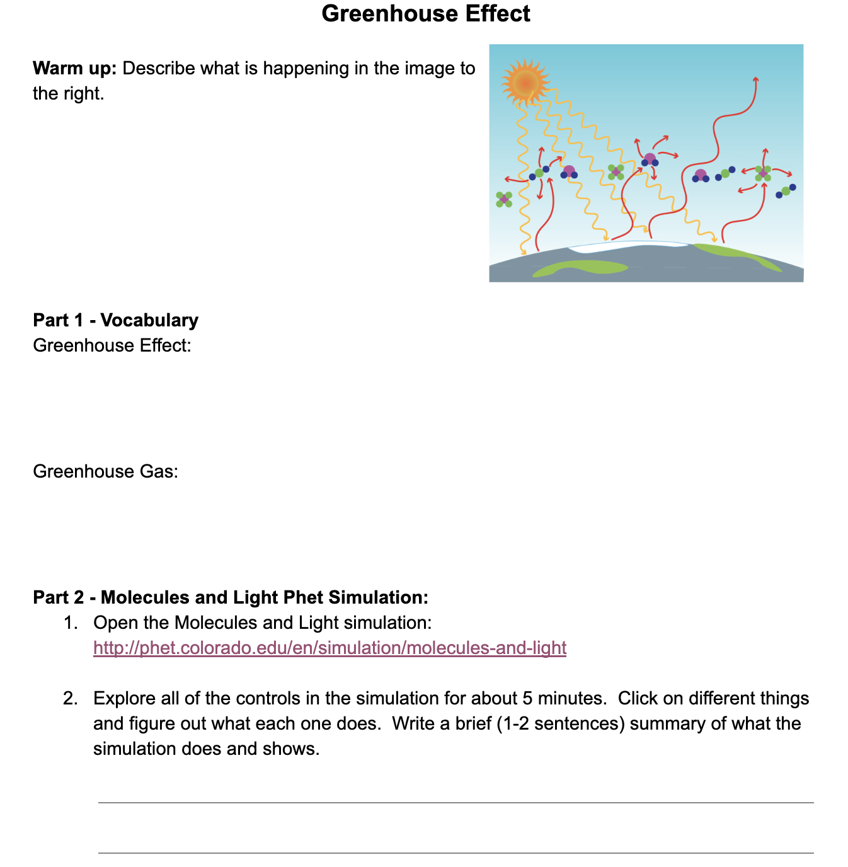
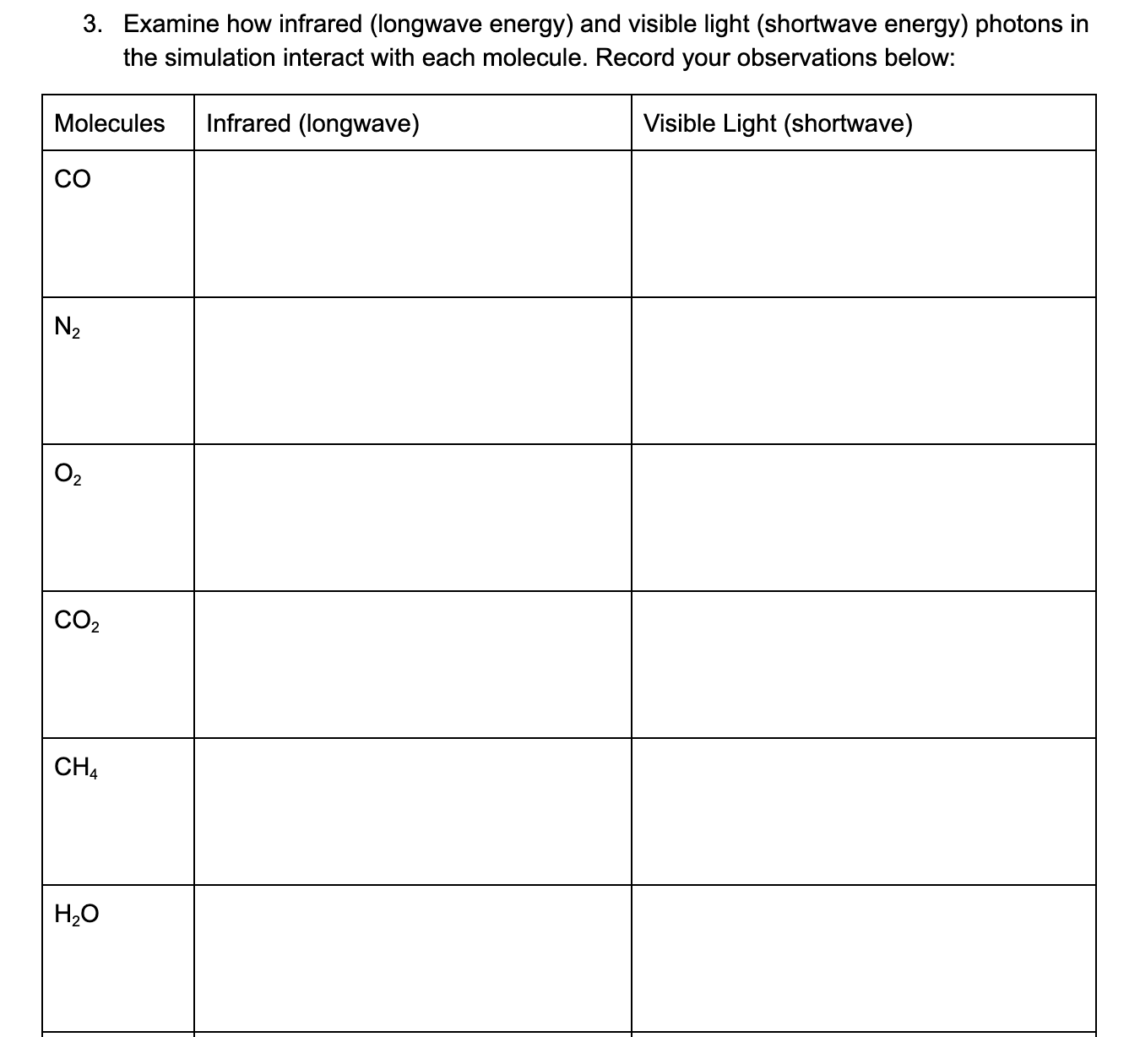

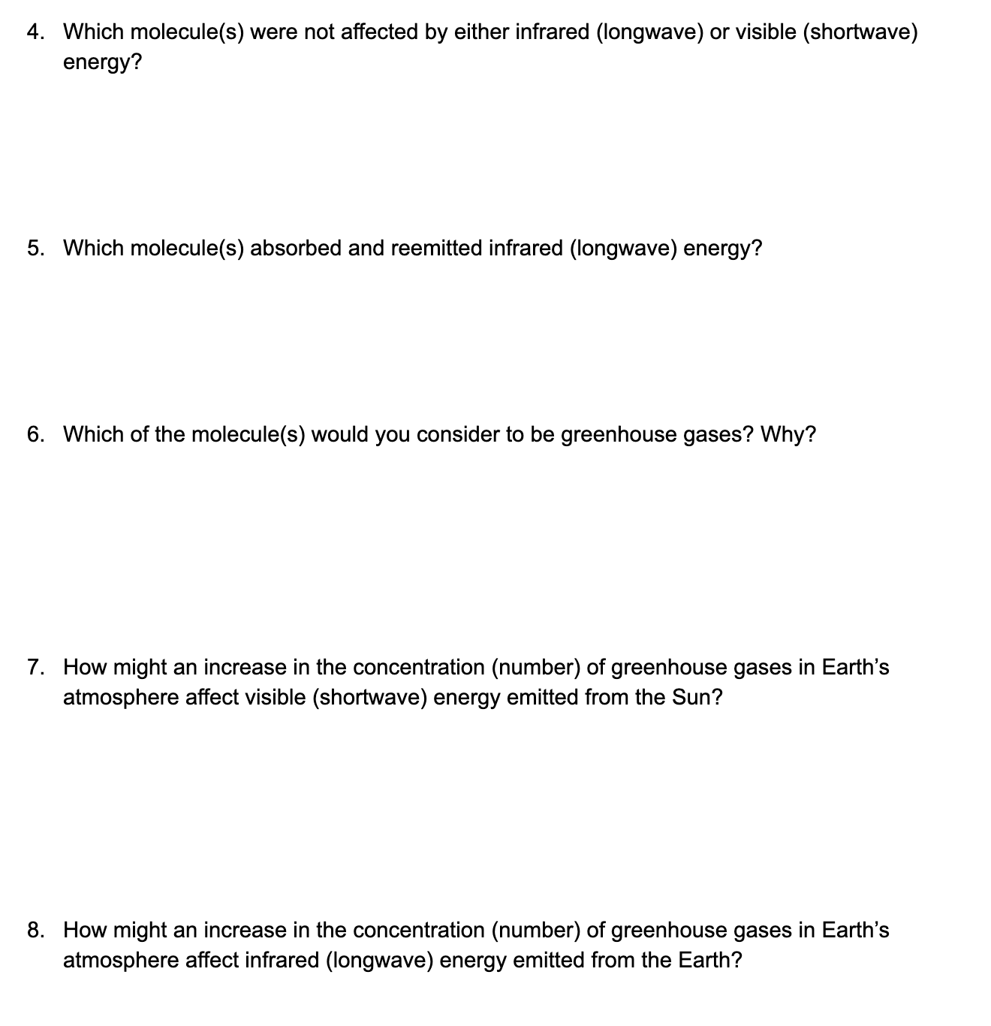

Name: ______________________________________________ Nov 28, 2022
Mr. Formaran

4.2 Concept 2

Global Wind Systems
https://www.youtube.com/watch?v=NQ3Tj-tdQIk

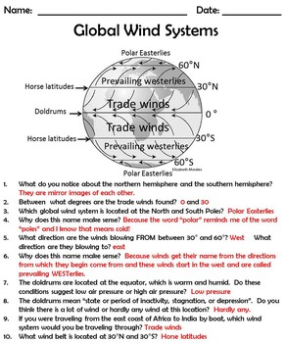
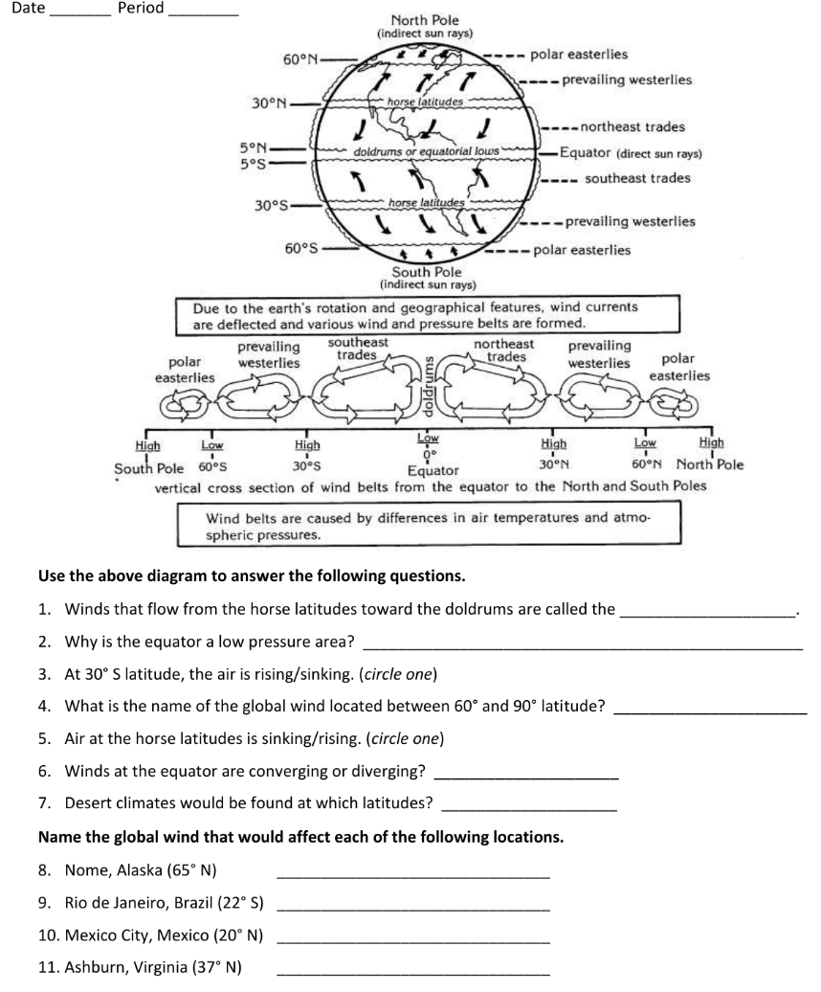
Name: ______________________________________________ Nov 30, 2022
Mr. Formaran

4.2 Concept 3

Continents and Oceans of the World
https://www.youtube.com/watch?v=VGxssWl99U8

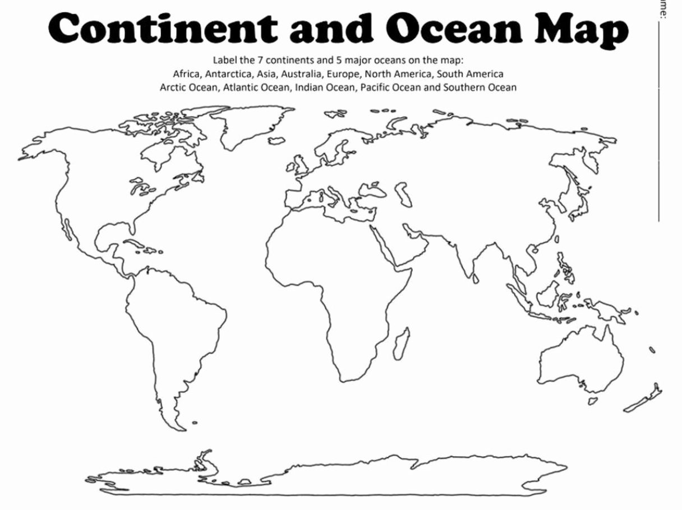

Ocean Currents
https://www.youtube.com/watch?v=1bxU6-8he_w

Why the Atlantic and Pacific meet but never mix
https://www.youtube.com/watch?v=NhBQfUVWLFk

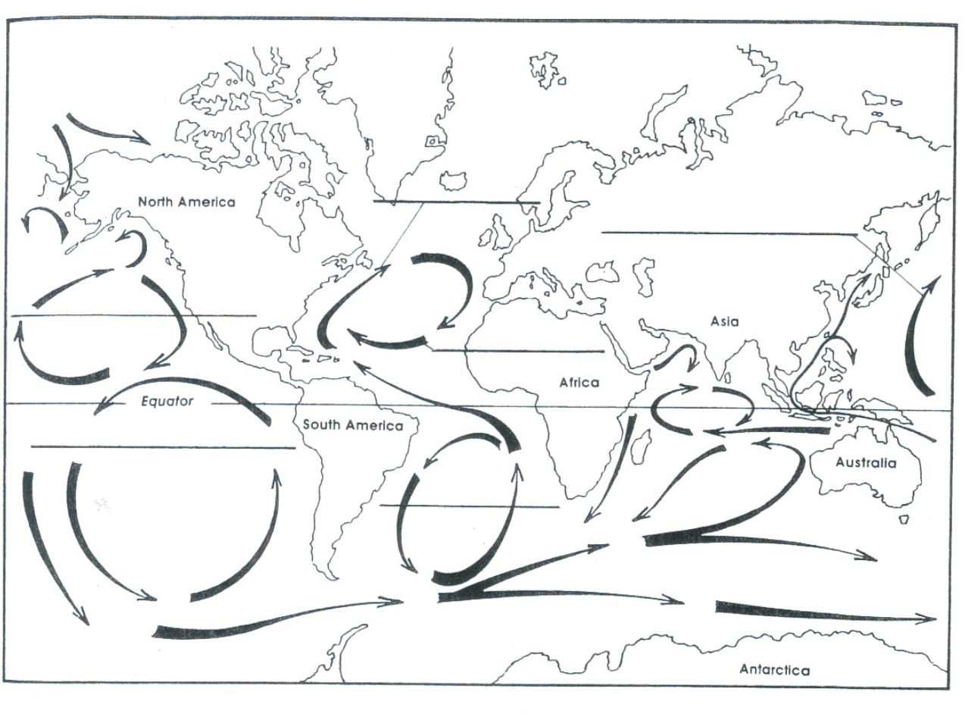
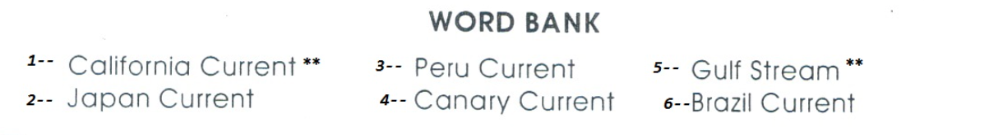
Write the number that correspond to the correct current.

Name: ______________________________________________ Dec. 1 , 2022
Mr. Formaran

4.2 Concept 4

Photosynthesis and Cellular Respiration
https://www.youtube.com/watch?v=rXzN89I4_Yk

