**AWM 11 – UNIT 5 – SLOPE AND RATES OF CHANGE**

|  |  |  |  |
| --- | --- | --- | --- |
| **Assignment** | **Title** | **Notes to Self** | **Complete** |
| **1** | ***Review – Ratios and Proportions*** |  |  |
| **2** | ***Cross Multiply and Divide*** |  |  |
| **3** | ***Working with Ratio*** |  |  |
| **4** | ***Working with Proportion*** |  |  |
|  | ***Quiz 1*** |  |  |
| **5** | ***Slope*** |  |  |
| **6** | ***Finding Rise or Run*** |  |  |
| **7** | ***Special Slopes*** |  |  |
| **8** | ***Angle of Elevation, Tangent, and Slope*** |  |  |
|  | ***Quiz 2*** |  |  |
| **9** | ***The Cartesian Coordinate System*** |  |  |
| **10** | ***Review - Simplifying Fractions*** |  |  |
| **11** | ***Calculating Slope of a Line*** |  |  |
| **12** | ***Special Slopes*** |  |  |
| **13** | ***Slope and Rate of Change*** |  |  |
| **14** | ***Slope and Rate of Change*** |  |  |
|  | ***Quiz 3*** |  |  |
| **Practice Test** | **Practice Test**  How are you doing? | Ask teacher. |  |
| **Self-Assessment** | **Self-Assessment** | On the next page, complete the self-assessment. |  |
| **Unit Test** | **Unit Test**  Show me your stuff! |  |  |

**Self-Assessment**

On the following chart, indicate how confident you feel about each statement.

**1 – I need more help 2 – I need more practice 3 – I could teach it !**

Discuss this with your teacher ***before*** you write the test!

|  |  |
| --- | --- |
| **Statement** | ☹ 😐 ☺ |
| After completing this chapter; |
| * I understand the relationship between rise, run, and slope |  |
| * I can calculate the slope given the rise and run of an object |  |
| * I can calculate the rise or run given the slope and the other part of the equation |  |
| * I can understand the special slopes referred to as percent grade and pitch. |  |
| * I can understand the relationship between slope and angle of elevation, and slope and the tangent ratio |  |
| * I can use Pythagorean Theorem and the tangent ratio to find the length of the hypotenuse and the angle of elevation |  |
| * I can plot or read the coordinates of a point on the Cartesian Coordinate system |  |
| * I can calculate the slope of a line from two points on that line |  |
| * I can determine the slope of vertical and horizontal lines |  |
| * I can identify the independent and dependent variables in a linear relationship |  |
| * I can create and interpret line graphs, and calculate the rate of change |  |

**Vocabulary: Unit 5**

angle of elevation

Cartesian coordinates

dependent variable

extrapolation

grade (percent grade)

hypotenuse

independent variable

interpolation

ordered pair

origin

pitch

proportion

Pythagorean Theorem

rate of change

ratio

rise

run

slope

tangent ratio

undefined slope

x-coordinate

y-coordinate

zero slope

**REVIEW – RATIOS AND PROPORTIONS**

A **ratio** is a comparison between two numbers measured in the same units.

A ratio can be expressed in three ways as shown below:

as a fraction 

in words by using the word “**to**” **9 to 16**

a notation using colon **: 9 : 16**

Ratios, like fractions, can be simplified. For example, the ratio **150 : 15** can also be expressed



which can be simplified 150 ÷ 15 = 10

15 ÷ 15 = 1

Notice that the numerator of the fraction is larger than the denominator. This can be common with ratios.

If two ratios are equivalent (equal), the first (top) term of each ratio compares to the second (bottom) term in an identical manner. You can represent this equivalence in the two ratios here:

 = 

An equation showing equivalent ratios is called a **proportion**.

**ASSIGNMENT 1 – RATIOS AND PROPORTIONS**

1) Write the following ratios in two other ways.

a)  b) 5 to 12 c) 18 : 11

2) Are the following proportions?

a)  =  b)  =  c)  = 

**Cross Multiply and Divide**

When two fractions are equal to each other, any unknown numerator or denominator can be found. The following example shows the process.

Example 1: Find ***x*** when  = 

Solution: Cross multiply means multiply the numbers across the equals sign (the arrow). The divide part means divide that result by the number opposite the unknown ( *x* ) as shown below.

 = 

This gives the result ***x*** = 3 × 2.1 ÷ 4

In other words, if  =  , then ***x*** = 3 × 2.1 ÷ 4 = 1.575

It does not matter where the unknown ( ***x*** ) is in the proportion, This process works for all situations.

This process can also be used when one side of the equal sign is not in fraction form.

Example 2: Find ***x*** when 27 = 

Solution:

Step 1. The number 27 is the same as  . So, place a 1 under the 27 to get:

 = 

Step 2. Cross multiply and divide as above  =  to solve.

So: ***x*** = 27 × 3 ÷1

***x*** = 81

**ASSIGNMENT 2 – CROSS MULTIPLY AND DIVIDE**

Find the missing term by using cross multiply and divide. If necessary, round answers to one decimal place. SHOW YOUR WORK.

1.  = 

2.  = 

3.  = 

4.  = 

**WORKING WITH RATIO**

Ratios can be used in word problems to express the relationship between parts.

Example:

Charlie works as a cook in a restaurant. His chicken soup recipe contains:

* 11 cups of seasoned broth
* 5 cups of diced vegetables
* 3 cups of rice
* 3 cups of chopped chicken

Write the ratios for each of the following relationships.

a) vegetables to chicken

b) broth to vegetables

c) chicken to rice

d) chicken to the total ingredients in the recipe

Solution:

a) vegetables to chicken is 5:3

b) broth to vegetables is 11:5

c) chicken to rice is 3:3 or 1:1

d) chicken to the total ingredients in the recipe is 3:22 (11 + 5 + 3 + 3)

**ASSIGNMENT 3 – WORKING WITH RATIO**

1) A conveyor belt has 2 pulleys. One pulley has a diameter of 45 cm and the other has a diameter of 20 cm. What is the ratio of the smaller diameter to the larger diameter?

2) On a bicycle with more than one gear, the ratio between the number of teeth on the front gear and the number of teeth on the back gear determines how easy it is to pedal. If the front gear has 30 teeth and the back gear has 10 teeth, what is the ratio of front teeth to back teeth?

3) What is the ratio of 250 mL of grape juice concentrate to 1 L of water?

(Hint: 1000 mL = 1L)

**WORKING WITH PROPORTION**

When given a ratio and one of the parts, write a **proportion** to solve using cross multiply and divide. Remember, a proportion is an equation showing equivalent ratios. Use a letter or word to represent the parts to put the numbers in the correct location.

Example: For a painting, Greg mixes inks to get the tint he wants. He uses a ratio of yellow ink to white ink of 3:1 and red ink to yellow in of 2:3.

a) How many mL of yellow ink would he use if he used 500 mL of white ink?

Solution: Set up a proportion using the known ratio and English letters/words to represent the colours.

yellow 3 = ***x***

white 1 500

***x*** = 3 × 500 ÷ 1 = 1500 mL of yellow ink

b) How many mL of red ink would he need if he used 750 mL of yellow ink?

Solution: Set up a proportion using the known ratio and English letters/words to represent the colours.

red 2 = ***x***

yellow 3 750

***x*** = 2 × 750 ÷ 3 = 500 mL of red ink

**ASSIGNMENT 4 – WORKING WITH PROPORTION**

1) If a secretary types 55 words in one minute, how long will it take the secretary to type a 2000 word report?

2) The ratio between Siu’s height and Tai’s height is 5:6. If Tai is 145 cm tall, how tall is Siu, to the nearest whole centimetre?

3) A mechanic can rotate the 4 tires on a truck in 15 minutes. How many minutes would it take the mechanic to rotate the tires on 5 trucks? Hint: what are you comparing??

**Ask your teacher for the quiz 1**

**SLOPE**

The **slope** of a line is the *steepness* of that line. It is the numerical value – a number – of how steeply something is slanted. The something could be a roof, a wheelchair ramp, a ski hill, or a road. Other words you may have heard associated with slope are pitch and grade. We will explore those later in the unit.

In mathematical terms, the slope is a ratio that compares the change in a vertical distance (↕) to the change in a horizontal distance ( ↔ ). Slope is the ratio between these two numbers and can be written like this:

slope = $\frac{change in vertical distance}{change in horizontal distance}$

The symbol for change is Greek letter delta which looks like this: Δ . We use it to replace the words “change in” so the formula looks like this:

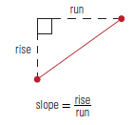 slope = $\frac{ Δ vertical distance}{ Δ horizontal distance}$

The change in the vertical distance is also called the “rise” while the change in horizontal distance is called the run. The variable used for slope is “**m**” (note the lower case). So the formula commonly used in math to describe slope is:

m = $\frac{ rise}{ run}$

When calculating the slope, the answer will have no units because it is a ratio not a measurement.

Example 1: Calculate the slope of a line if the rise is 8 and the run is 4.

Solution: To calculate the slope when given the rise and the run, substitute the values into the equation and divide.

m = $\frac{ rise}{ run}$

m = $\frac{ 8}{ 4}$

m = 8 ÷ 4 = 2 The slope is 2 (no units).

Note that is it acceptable and sometimes useful to record your answer in the reduced fraction form. An example of this is $\frac{ 2}{ 1}$ to indicate the rise and the run.

**ASSIGNMENT 5 – CALCULATING SLOPE**

1) Complete the table below with slope as a fraction and as a decimal (2 decimal places).

|  |  |  |  |
| --- | --- | --- | --- |
| ***Rise*** | ***Run*** | ***Slope*** | |
| *Fraction ( m = $\frac{ rise}{ run}$)* | *Decimal* |
| 15 in | 67 in |  |  |
| 2 cm | 25 cm |  |  |
| 18.5 mm | 5.2 mm |  |  |

2) Calculate the slope of the following. Show your work!

a) A ramp has a rise of 5 feet and a run of 25 feet.

b) A children’s slide has a rise of 2.5 m and a run of 4.2 m.

c) A hill rises 12 metres over a horizontal distance of 8 metres.

d) An eavestrough has a rise of 1 inch and a run of 60 inches.

e) The roof on my house covers 24 feet horizontally and is 6 feet high.

**FINDING RISE OR RUN**

If you are given the slope, and another value for either the rise or the run, you can calculate the missing value using a proportion and the process of Cross Multiply and Divide.

Example 1: If the slope of a line is $\frac{ 8}{ 15}$ and the rise is 20, what is the run?

Solution: Substitute the values in a proportion and solve for the unknown.

m = $\frac{ rise}{ run}$

$\frac{ 8}{ 15}$ = $\frac{ 20}{ run}$

run = 15 × 20 ÷ 8 = 37.5 The run is 37.5

Sometimes the slope will be given as a decimal number. To make this a fraction, write it with a denominator of 1.

Example 2: A hill has a slope of 0.75. How many metres will the run be if the rise is

27 metres?

Solution: Substitute the values in a proportion and solve for the unknown.

m = $\frac{ rise}{ run}$

0.75 = $\frac{ 27}{ run}$ Make the denominator on the first fraction 1.

$\frac{ 0.75}{ 1}$ = $\frac{ 27}{ run}$ Cross multiply and divide.

run = 1 × 27 ÷ 0.75 = 36 The run is 36 metres

Example 3: A ramp is constructed in two sections with the same slope. The first section has a rise of 12 feet and a run of 67 feet. The second section has a run of 98 feet, what is the rise?

Solution: Substitute the values in a proportion and solve for the unknown.

m = $\frac{ rise}{ run}$

$\frac{ 12}{ 67}$ = $\frac{ rise}{ 98}$

rise = 12 × 98 ÷ 67 = 17.552 The rise is 17.6

**ASSIGNMENT 6 – FINDING RISE OR RUN**

1) The slope of a street is $\frac{ 27}{ 50}$. If the run is 28 metres, what is the rise?

2) If the rise of a hill covers a vertical distance of 45 metres, and the slope of the hill is $\frac{ 4}{ 25}$, what is the run?

3) The slope of a staircase is 0.65. If the horizontal distance covered by the staircase is 200 m, what is its rise?

4) A waterslide has a vertical height of 9 metres. If the slope of the slide is 0.93, what horizontal distance does it cover?

5) A ladder needs a slope of 1 foot of run for every 4 feet of rise. If the ladder needs to reach 36 feet above the ground (vertical distance), what should the run for that ladder be?

6) The slope of a ditch needs to be 2 cm deep for every 1250 cm across. How much will the rise be if the run is 25 000 cm (25 m)?

**SPECIAL SLOPES**

There are several words associated with slope that have special meanings. These include *grade* and *pitch*. While they all are examples of slopes, they apply in different situations.

**Grade** refers to the slope of a hill. When driving in British Columbia we have all seen signs that refer to the grade of a road on a hill. Grade is simply slope expressed as a percent. This is important information for truck drivers who are approaching a steep hill. Often, there are roadside pull outs before steep hills for truck drivers to check their brakes so they can safely negotiate the hill. As well there might be runaway lanes on steep grades that help trucks stop in case their brakes fail.

To calculate the grade of a hill on a road, find the slope and then multiply it by 100. This is referred to as the percent grade.

percent grade = $\frac{ rise}{ run}$ × 100

Example 1: George is driving along the highway and sees a sign that says he is coming to a hill with a 9% grade. Express the slope of this road as a fraction.

Solution: A grade of 9% means a rise of 9 units for every 100 units of run.

m = $\frac{ rise}{ run}$

m = $\frac{ 9}{100}$ The slope as a fraction is $\frac{ 9}{100}$

Example 2: A steep road rises 700 m over a length of 8 km. What is the percent grade of this road?

Solution: Convert km to m; then substitute the values into the equation and calculate.

1 km = 1000 m so 8 km = 8000 m

percent grade = $\frac{ rise}{ run}$ × 100

percent grade = $\frac{ 700}{ 8000}$ × 100

percent grade = 700 ÷ 8000 × 100 = 8.75% grade

The grade of the road is 8.75%

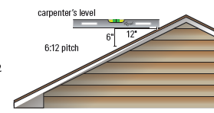The slope of a roof is often referred to as the **pitch** of the roof. The pitch of a roof can be expressed as the number of inches of rise compared to the number of inches of run. So a pitch might be written as 6:12, like the roof in the picture.

This is not the only ratio used to express pitch. Remember that the pitch is just another way to describe the slope of the roof. It is always defined as rise over run.

It is worthwhile noting that while Canada is a metric country, and has been since the 1980s, there are many things, especially in the construction industry, that are still measured and thought of in the imperial units of inches and feet. Pitch is usually measured in this way.

Pitch can also be used to refer to other climbing things such as a staircase, whether it is the whole flight of stairs or an individual step.

Example 3: The pitch of a roof against a house is 5:8. What is the slope of the roof?

Solution: Write the pitch as a fraction, rise over run, and divide.

**pitch =** **slope = rise : run = $\frac{rise}{run}$ = $\frac{5}{8}$ = 0.625**

Example 4: The pitch of a lean-to roof against a house is 3:4. If the floor of the lean-to is 5.2 m long, what is the maximum height of the lean-to?

Solution: Substitute the values in a proportion and solve for the unknown.

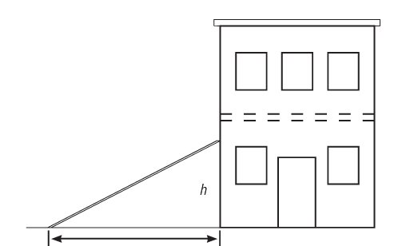A pitch of 3:4 is a slope of $\frac{3}{4}$. Use the proportion to solve.

m = $\frac{rise}{run}$

$\frac{3}{4}$ = $\frac{rise}{5.2}$

rise = 3 × 5.2 ÷ 4 = 3.9 The height of the roof is 3.9 metres.

Example 5: If the slope of a roof is said to be 12.25%, express the slope as a non-percent number.

Solution: To express any number as a non-percent number, divide the number by 100.

slope = 12.25%

slope = 12.25% ÷ 100 = 0.1225

The slope is 0.1225

**ASSIGNMENT 7 – SPECIAL SLOPES**

1) Nathan is building a ramp for his dirt bike. If the rise is 8m and the run is 22 m, what is the percent grade of his ramp to the closet whole number?

2) In 1885, the CPR built a railway line from Field, BC through the Kicking Horse Pass. At the time, it was one of the steepest railway tracks in the world. The line dropped 300 m over 6 km. What was the percent grade of the hill?

3) Samuel uses a helicopter to harvest the logs from slopes that have a grade of more than 10%. If the hill he is looking at has a rise of 19 m and a run of 157 m, will he have to use a helicopter?

4) If the slope of a ramp is 15.5% and the run is 18 m, what is the rise?

5) The pitch of a garden shed is 3:5. If the shed is 8 m

wide as illustrated, how tall is the roof (rise)?

8 m

6) The roof of one house has a pitch of 6.7:18 while the second house has a pitch of 4.5:12. Which roof is steeper?

**ANGLE OF ELEVATION, TANGENT AND SLOPE**

There is a relationship between the angle of elevation, tangent ratio and slope. Before we discuss this relationship, a review of these concepts is necessary.

Remember that **Pythagorean Theorem** states that in any right triangle, the sum of the squares of the lengths of the legs is equal to the square of the length of the hypotenuse. So in ΔABC with the right angle at C, the following relationship is true:

c2 = a2 + b2

where a and b are the other 2 legs of the triangle.

c

b

a

When we look at trigonometry, we consider the sides in their relationship to the angle of interest, θ. The sides are referred to as hypotenuse, opposite and adjacent.

h = hypotenuse

h o o = opposite

a = adjacent

θ

a

The **tangent of angle θ** means the ratio of the opposite side to the adjacent side. It is abbreviated as **tan θ** but read as tangent θ. It is written like this:

tan θ =  or tan θ = $\frac{o}{a}$

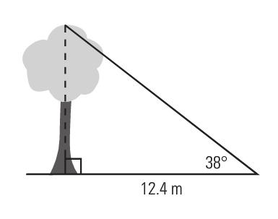Finally, the **angle of elevation** is the angle between the horizontal and your line of sight. In the diagram to the right, the angle of elevation is the angle marked as 380 – between the ground (horizontal) and the top of the tree (line of site).

So how does this all fit together? First let’s look at how the Pythagorean Theorem and the tangent ratio work together.

In the triangle below, the Pythagorean Theorem states that c2 = a2 + b2

c

b

θ

a

But if we look at trigonometric ratios for the same triangle,

c = h b = o a = a

So tan θ = $\frac{o}{a}$ and using the side letter names, tan θ = $\frac{b}{a}$ or 

From this relationship, the length of hypotenuse and the size of ∠θ can be found.

Example 1: Using the diagram, calculate the length of the hypotenuse A

and size of ∠θ.

Solution: Use Pythagorean Theorem to solve for the length of the

hypotenuse and the tangent ratio to solve for ∠θ. 3.5 m

c2 = a2 + b2  θ

c2 = 4.12 + 3.52 C 4.1m B

c2 = 16.81 + 12.25

c2 = 29.06

=

c = 5.39 m

To find ∠θ, use the following ratio;

tan θ = $\frac{b}{a}$

tan θ =

θ = tan-1 (3.5 ÷ 4.1) = 40.486 = 400

The length of the hypotenuse is 5.39 m and angle θ is approximately 400.

The angle shown in the previous example has another name. It is the angle of elevation. So when finding the slope of the hypotenuse we are finding the tangent of angle θ and when finding the angle θ, we are finding the angle of elevation. This holds true as long as these components of the triangle are in the same location as the previous diagram. If the angle in the triangle is the other acute angle, we are NOT finding the angle of elevation.

Example 2: Find the slope of the hypotenuse in fraction form, and use it to find the angle of elevation.

Solution: The slope of the hypotenuse is the rise divided by the run.

Use the tangent ratio to solve for the angle of elevation. 2.7 cm

θ

The slope of the hypotenuse is the rise divided by the run. 5.7 cm

m = $\frac{ rise}{ run}$

m = $\frac{2.7}{5.7}$

m = $\frac{27}{57}$ Multiply numerator and denominator by 10 to eliminate decimals.

m = $\frac{9}{19}$ Divide numerator and denominator by 3 to reduce.

The slope of the hypotenuse is = $\frac{9}{19}$. Leave this as a fraction.

Use the tangent ratio to solve for the angle of elevation.

tan θ = $\frac{o}{a}$

tan θ = m

tan θ =

θ = tan-1 (9 ÷ 19) = 25.346 = 250

The slope of the hypotenuse is $\frac{9}{19}$, and angle θ is approximately 250.

**ASSIGNMENT 8 – ANGLE OF ELEVATION, TANGENT AND SLOPE**

1) Complete the table below. Round angles to the closest whole number, and rise and run to the nearest whole number.

|  |  |  |  |  |
| --- | --- | --- | --- | --- |
| **Rise** | **Run** | **Slope as Fraction** | **Slope as Decimal** | **Angle of elevation** |
| 28 | 48.5 | $$\frac{28}{48.5}$$ | 0.5773 | tan-1 (0.5773) = 300 |
|  | 13 |  | 2.36 | tan-1 (2.36) = _______ |
| 5 | 8 |  |  |  |
| 49 |  |  |  | tan-1 (0.488) = _______ |

2) A skateboard ramp has a rise of 3 feet and a run of 4 feet.

a) Calculate the **length** of the ramp. ramp

b) What is the angle of elevation of the ramp?

3) Find the slope of the hypotenuse in fraction form, and use it to find the angle of elevation.

50 ft

30 ft

4) Calculate the slope of the hypotenuse and the angle of elevation for the triangle below.

25 m

35 m

5) Andrew is installing a pipe to drain water for a landscaper. The pipe must have a drop (rise)

of 2.5 cm for a run of 3.5 m (350 cm). (The picture is not drawn to scale.)

350 cm

a) What is the slope of the pipe? θ

2.5 cm

pipe

b) How much drop will Andrew need if the run is 12 m (or 1200 cm)?

c) What is the angle of depression, θ, of the pipe?

**Ask your teacher for quiz 2**

**THE CARTESIAN COORDINATE SYSTEM**

Slope can also be calculated from the values of points on a line using a formula. How is this done? First, you must know the coordinates of 2 points on that line, and the use the formula. Before investigating the formula, review of the Cartesian coordinate system is necessary.

The **Cartesian coordinate system** is a grid that identifies the location of a point by a pair of numbers which are a specific distance from a fixed point called the **origin** (For our purposes, we are only using 2-dimensions but 3-dimensions can be used!).

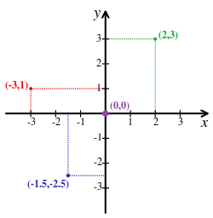The grid is shown, with several points marked. Notice that the points are located by 2 lines, one horizontal and the other vertical. When marking a point on a grid system, the first number indicates how far right or left of the origin (0,0) the point is (x-coordinate), and the second number indicates how far up or down the point is (y-coordinate). With these two values, any point can be plotted.

Each reference line is called an axis, and they cross at the origin. For each axis, one half is positive (right and up) and the other half is negative (left or down). This is like two number lines – one horizontal and one vertical. You can see this reflected in the points plotted to the right.

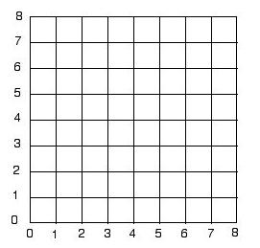

For the purposes of this course, we will only deal with the **FIRST** quadrant of the grid, where both numbers have a positive value.

Identifying the locations of points on this grid is called naming the points. As mentioned before, we put the coordinates in parentheses, with the x-coordinate first and the y-coordinate second.

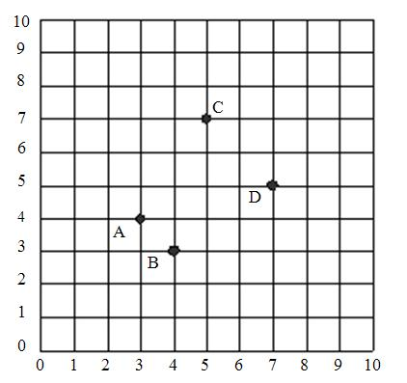

Example 1: Name the coordinates on the grid.

Solution: First, count from the origin to the right, and second count how far up each point is.

A ( 3, 4 )

B ( 4, 3 )

C ( 5, 7 )

D ( 7, 5 )

Example 2: Plot the point ( 2, 5 ).

Solution: Start at the origin ( 0, 0 ) and move 2 units to the right and then 5 units up. Mark the location with a small dot as shown.

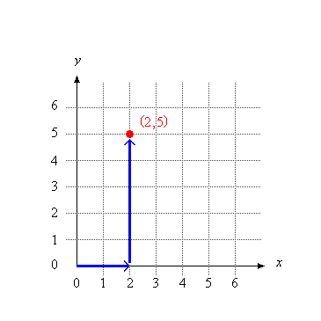

**THIS IS REALLY IMPORTANT TO REMEMBER**!

**ASSIGNMENT 9 – ORDERED PAIRS**

Using the grid below, answer the following questions.



1) Name the letter of the point located at each of the following coordinate pairs.

_____ ( 10, 0 ) _____ ( 5, 8 )

_____ ( 8, 7 ) _____ ( 2, 12 )

_____ ( 7, 7 ) _____ ( 0, 10 )

2) Write the ordered pair for each given point.

N _________ R _________

O _________ G _________

J _________ F _________

3) Plot the following points on the coordinate grid.

S ( 3, 6 ) T ( 8, 2 ) U ( 10, 8 )

W ( 5, 5 ) X ( 4, 2 ) Y ( 2, 7 )

**REVIEW – SIMPLIFYING FRACTIONS**

To simplify a fraction, divide the numerator and denominator by a common factor. Easy common factors to start with are 2 for even numbers, 3, or 5. If the resulting fraction cannot be divided by any other common factor, then it is in **lowest terms**. If it can be divided again by another common factor, keep repeating the process until it is in lowest terms.

Example 1: Simplify 18 numerator

27 denominator

Solution A: 18 ÷ 9 = 2 Simplify, using a factor of 9

27 ÷ 9 = 3

Solution B: 18 ÷ 3 = 6 ÷ 3 = 2 Simplify, using a factor of 3, twice

27 ÷ 3 = 9 ÷ 3 = 3

**ASSIGNMENT 10 – SIMPLIFYING FRACTIONS**

1) Simplify these fractions to their lowest terms. Show your work!

a) $\frac{4}{16}$ b) $\frac{3}{12}$ c) $\frac{25}{75}$

d) $\frac{15}{21}$ e) $\frac{8}{18}$ f) $\frac{45}{100}$

g) $\frac{20}{50}$ h) $\frac{3}{21}$ i) $\frac{7}{56}$

**CALCULATION OF SLOPE OF A LINE**

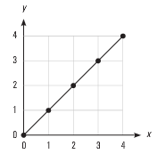When calculating slope, you will always be working with a straight line. These lines will have identifiable points plotted along them.

To calculate the slope of such a line, two points are needed. You can see from this example that there are 5 usable points. Any 2 can be used – it doesn’t matter which ones. And it doesn’t matter which point you start with. Usually it is a good idea to choose the point with the bigger values.

When you choose the two points, they must be in the form ( x , y ) – that means that you read the x-coordinate first followed by the y-coordinate.

Slopes can be positive or negative. If the line goes up to the right, the slope is positive (graph on the left). If it goes down to the right, the slope is negative (graph on the right). Slope of a line has no units, it is just a numerical value; just a number.

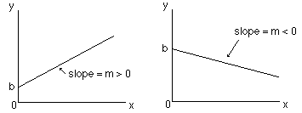

The slope is calculated as the change in the vertical distance divided by the change in the horizontal distance. The letter “*m*” is used to represent slope. The formula used to calculate slope is:

*m* = $\frac{y-y}{x-x}$

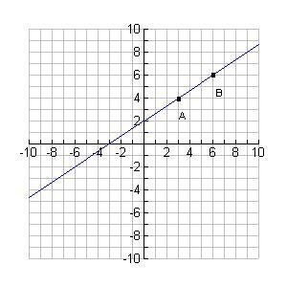

Example 1: Using the formula to calculate slope, find the slope of the line shown on the graph.

Solution: To calculate the slope of a line, choose 2 points on that line. It is easier and more accurate to choose points that lie on the intersection of the two grid lines. The two points are marked on the graph.

Point A (3, 4) Point B (6, 6)

The slope is the change in the values as we move from point A to point B. The symbol Δ*x* ("delta *x*") means how much the *x*-coordinate will change (as we move from A to B). And the symbol Δ*y* ("delta y") means how much the *y*-coordinate will change.

The slope of the line, *m*, is:

*m = $\frac{Δy}{Δx}$ = $\frac{y-y}{x-x}$ = $\frac{Change in the rise}{Change in the run}$*

Remember, the rise is always the change in the y and the run is always the change in the x. It does not matter which point you start with.

So, using the coordinates above, **B** is (6, 6), and **A** is(3, 4), then the slope of that line is

*m = $\frac{Δy}{Δx}$ = $\frac{y-y}{x-x}$ = $\frac{6-4}{6-3}$*  = $\frac{2}{3}$ = 0.6 = 0.7

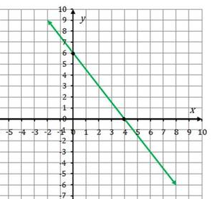Example 2: Calculate the slope of the following line.

Solution: Choose 2 points and use the slope formula to calculate the answer.

There are several points that can be used: two are marked on the grid ( 4, 0 ) and ( 0, 6 ). Another point that could be used is ( 2, 3 ). All the other potential points only cross one grid line so the other value would be estimated. This is not a good choice.

Use ( 4, 0 ) and ( 2, 3 ).

*m = $\frac{Δy}{Δx}$ = $\frac{y-y}{x-x}$ = $\frac{3-0}{2-4}$*  = $\frac{ 3}{-2}$ = 3 ÷ – 2 = –1.5

Because the line slopes down to the right, it has a negative slope.

The slope of this line is –1.5.

**NOTE**: If we had chosen any combination of the three points, ( 4, 0 ), ( 0, 6 ), or ( 2, 3 ) the answer would have been the same. Here is proof.

Use ( 0, 6 ) and ( 2, 3 ).

*m = $\frac{Δy}{Δx}$ = $\frac{y-y}{x-x}$ = $\frac{3-6}{2-0}$*  = $\frac{- 3}{ 2}$ = – 3 ÷ 2 = –1.5

If you are given the slope of a line and the coordinates of any point on the line, it is possible to plot that line.

Example 3: Plot a line on the graph that goes through (1, 3) and has a slope of 2. Write the coordinates of 2 other points that are on that line.

Solution: First plot the point on the grid.

Next, use the slope to plot other points as follows:

Make the slope into a fraction by using a denominator if 1.

Remembering that slope = $\frac{ rise}{ run}$, fill this in with your slope.

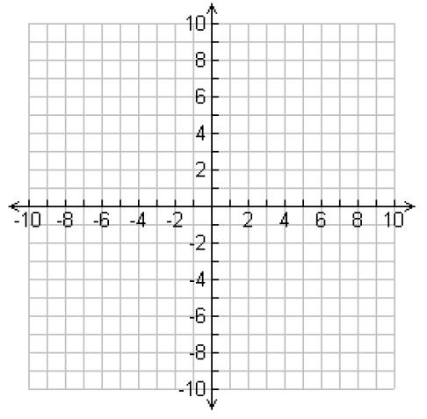So, slope = $\frac{ rise}{ run}$ = $\frac{ 2}{ 1}$

For this line then, the rise = 2 and the run = 1. Use this to plot new points on the graph by starting at the original point (1, 3) and RISING 2 and RUNNING 1 from each point to the next new one. A minimum of 3 points is needed.

Join the points with a straight line covering the whole grid space.

Write the coordinates of any 2 points that fall on the line. Examples include:

(2, 5) or (4, 9) or (0, 1) or (-1, -3)

Remember to choose points where the line is on top of a cross of both gridlines.

**ASSIGNMENT 11 – CALCULATING SLOPE OF A LINE**

1) Calculate the slope for each of the following pairs of points. State whether the line would slope up or down to the right.

a) A (2, 2) B (6, 3) b) C (5, 1) D (3, 2)

c) E (12, 8) F (2, 10) d) G (1, 4) H (3, 1)

2) For each of the following graphs, state whether the slope is positive or negative. Then calculate the slope.

a) b)



c) d)

3) Plot a line on the graph that goes through (4, 2) and has a slope of 3. Write the coordinates of 2 other points that are on that line.



**SPECIAL SLOPES**

There are two special lines that give unique slopes. That means that lines like these always have the same slopes. These lines are horizontal and vertical lines.

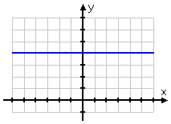

A horizontal line is always parallel to the x-axis. It runs across the page. Regardless of which points you choose on a horizontal line, they will always have the same y-coordinate because the line is the same distance up from the x-axis.

In the example here, every point on this line has a y-coordinate of 4. So some examples of points on the line would be (1, 4), (0, 4), (10, 4), (3, 4), (5, 4), (2, 4), (4, 4) and so on. The list is limitless.

When calculating the slope of this line then, the top of the formula (called the numerator) will always be 4 – 4 = 0. So the slope will be zero. This proves the rule that says the slope of any horizontal line is zero. This makes sense if we remember what slope is: the steepness of the line. A flat line has no steepness!

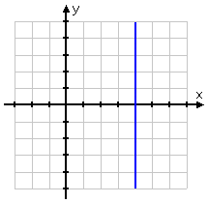

A vertical line on the other hand, is always parallel to the y-axis. It runs up and down. Regardless of which points you choose on a vertical line, they will always have the same x-coordinate because the line is the same distance up from the y-axis.

In the example here, every point on this line has an x-coordinate of 4. So some examples of points on the line would be (4, 1), (4, 0), (4, 10), (4, 3), (4, 5), (4, 2), (4, 4) and so on. The list is limitless.

When calculating the slope of this line then, the bottom of the formula (called the denominator) will always be 4 – 4 = 0. So the slope will be a formula trying to divide by zero. If you try this on your calculator, it will give you a message that says “Error.” In Math, when we have a fraction number has a denominator of zero, we say the fraction is **undefined**. So the slope is undefined. This makes sense if we remember what slope is: the steepness of the line. A vertical line is completely steep – it can’t be made steeper.

**ASSIGNMENT 12 – SPECIAL SLOPES**

1) Which line looks like it has a slope of zero and which looks as if it has an undefined slope?

 Slope: ____________ Slope: ____________

2) Use the slope formula to verify the slope of each line above. Show your work.

3) Use the slope formula to calculate the slope of the line joining each pair of points. Then indicate if the line would be vertical, horizontal, sloping upwards or sloping downwards?

a) (40, 100) and (40, 200) b) (4, 8) and (9, 5)

c) (2.3, 0.1) and (8.3, 0.2) d) (25.4, 6.7) and (28.5, 6.7)

**Slope and RATE of CHANGE**

Up until this point, we have looked at a graph as having an x-axis and a y-axis, which of course they do. But when looking at a straight line or linear graph as the ones we examining are, we can analyze the graph a little differently.

When you compare the *change* in the y variable to the *change* in the x variable as we have been doing to calculate the slope of the line, it is referred to as a **rate of change**. The rate of change therefore, is the rate at which one variable changes compared to another variable.

One variable is always referred to as the **dependent variable** because its value depends on another variable called the independent variable. The **independent variable** is a variable whose vales may be chosen. It is important to understand that the dependent variable must always be calculated based on the independent variable. It is necessary to be able to determine the relationship between two variables, and to determine which is the dependent and which is the independent variable.

Example: Identify the dependant and the independent variable in the following situation.

the gross pay earned in a week or the hours worked that week

Solution: Identify which variable you can choose and which variable must be calculated based on the other one.

In this case, the independent variable is the number of hours worked because you can choose how many hours you work. The dependent variable –the gross pay earned- “depends” on how many hours you worked, and is calculated by multiplying the hours by your hourly rate.

**ASSIGNMENT 13 – DEPENDENT AND INDEPENDENT VARIABLES**

1) Identify the independent and dependent variables in each pair below.

a) number of paperclips in my hand / the mass of those paperclips

b) the distance travelled on my bike / the time I rode my bike

c) the number of boxes of chocolates sold / the profit made

d) the total cost for stamps at the post office / the number of stamps I bought

e) the commission income earned / the amount of sales

As stated earlier, the rate of change is the slope of the line on a graph. When a relationship remains constant, it produces a straight line graph like the ones we have been calculating the slope of. Remember, it doesn’t matter which points you choose on the line to calculate the slope – it remains the same. So any two points will produce the same rise over run.

When asked to write an equation (or formula) of the line, it follows the format:

**dependent variable = slope × independent variable**

Example1: Identify the independent and dependent variables, calculate the slope of the line, and write an equation (formula) to describe relationship shown.

Solution: The dependent variable is ***always*** along the y-axis (vertical), so on this graph, the dependent variable is the distance travelled in km. The independent variable is ***always*** along the x-axis (horizontal) so it is the time in hours.

To calculate the slope, pick any two points. We will use: (2, 100) and (4, 200)

*m = $\frac{Δy}{Δx}$ = $\frac{y-y}{x-x}$ = $\frac{200-100}{4-2}$*  = $\frac{ 100}{2}$ = 100 ÷ 2 = 50

The slope is 50, so the rate of change is 50 km for every hour or 50 km/h.

The equation of the line is in the form of *dependent variable = slope × independent variable*

Let distance travelled (dependent variable) be *d* and the time (independent variable) be *t*.

The equation or formula of the line would be:

*d* = 50 × *t* or *d* = 50*t*

Example 2: Michelle is a clerk who earns $15.00 per hour.

a) Identify the dependent and independent variables in this relationship.

b) Using *e* for earnings and *h* for hours, write an equation to show the relationship between Michelle’s hours worked and her earnings.

c) Using values of your choice make a graph of this relationship.

d) Calculate the slope of the line.

e) How much will Michelle earn in 5 hours? Interpolate using the graph.

f) If Michelle earned $180.00 one week, how many hours did she work? Extrapolate using the graph.

Solution:

a) The independent variable is the number of hours Michelle works and her earnings is the dependent variable. Looking at part b) helps determine what the variables are. Use the rest of the question to help you!

b) To calculate the earnings = $15.00 × hours worked so the equation would be

*e* = $15.00 × *h* or *e* = 15*h*

c) An easy way to create points for plotting is to make a Table of Values. This is just the data organized on a way that is easy to calculate and easy plot from. Place the independent variable on the top line and choose your values (or fill it in with the given values). Then calculate the appropriate value for the dependent variable which goes on the bottom line.

To complete the bottom line, the following calculations are made.

7 × $15.00 = $105.00 4 × $15.00 = $60.00 6 × $15.00 = $90.00

8 × $15.00 = $120.00 3 × $15.00 = $45.00

|  |  |  |  |  |  |
| --- | --- | --- | --- | --- | --- |
| Hours worked | 7 | 4 | 6 | 8 | 3 |
| Earnings | $105.00 | $60.00 | $90.00 | $120.00 | $45.00 |

The graph below shows the data plotted from the Table of Values.

Now use your ruler and join the points as shown below.

d) To calculate the slope, use any two points on the line. These can also come from the Table of Values.

This example will use the first two points: (7, 105) and (4, 60)

*m = $\frac{Δy}{Δx}$ = $\frac{y-y}{x-x}$ = $\frac{105-60}{7-4}$*  = $\frac{ 45}{ 3}$ = 45 ÷ 3 = 15

Notice that the slope is the hourly wage – $15.00 – which proves the statement discussed earlier that when writing an equation of the line (or a formula for the line),

*dependent variable = slope × independent variable*

e) **Interpolation** is the process where we estimate a value between two known values. To interpolate from the graph, find the value on one axis – in this case the value is 5 hours – and go straight up till you reach the line joining the points. Then read the value from the other axis – in this case it would be $75.00. Note that interpolation can start from the vertical axis and then go down to the x-axis.

f) To determine a value that occurs past the points of data, use the process of **extrapolation**. This means to estimate the value beyond the range of data by extending the line based on the previous data. To extrapolate from a graph, draw a dashed line from the end of the last data point following the trend to the edge of the graph.

To extrapolate to find the number of hours worked for the earnings of $180.00, find the value of $180.00 on the vertical axis. Go to the right horizontally until the dashed line is reached. Then go vertically down until you reach the x-axis. Read the value at that point. For this line, the value would be 12 hours.

Remember that slopes can be negative and therefore the process is the same but the line will slope down to the right. In a situation where a line has a negative slope, the dependent variable will decrease as the independent variable increases. The following graph shows an example of this type of situation.

**ASSIGNMENT 14 –RATE OF CHANGE**

1) Use the graph below to answer the following.

a) Identify the independent and dependent variables.

b) Calculate the slope of the line. Remember it’s sloping down to the right so it will be a negative slope.

c) Write an equation to describe the relationship shown.

2) Maurice is a salesman and earns a commission of 15% on all his sales.

a) Identify the independent and dependent variables in this relationship.

b) Complete the Table of Values below to calculate how much commission Maurice makes on the sales given.

|  |  |  |  |  |  |
| --- | --- | --- | --- | --- | --- |
| Sales | $1000 | $2000 | $5000 | $8000 | $9000 |
| Commission earned |  |  |  |  |  |

c) Create a graph to represent this relationship on the grid paper below.



d) Calculate the slope of the line of this relationship.

e) Write an equation to represent this relationship using ***c***for commission and ***s*** for sales.

3) The graph below shows a plane’s altitude as it descended to land. At what rate does the plane descend? (Find the slope of the line!)

4) Daniel and Henrick have weekend jobs. Daniel earns $73.20 in 6 hours while Henrick earns $55.50 in 5 hours.

a) Calculate their earnings for the two times given and for 2 other different lengths of time. Record these values in the Table of Values below.

|  |  |  |  |  |  |
| --- | --- | --- | --- | --- | --- |
| Hours | 1 | 6 | 5 |  |  |
| Daniel’s earnings |  |  |  |  |  |
| Henrick’s earnings |  |  |  |  |  |

c) Who makes more money after an 8-hour shift?

d) What are Daniel and Henrick’s rate of earnings?

5) Which of the following graphs has the steeper slope? Show your calculations.

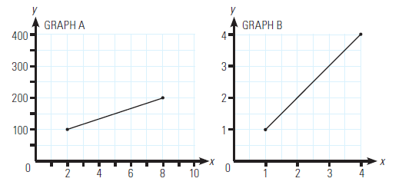

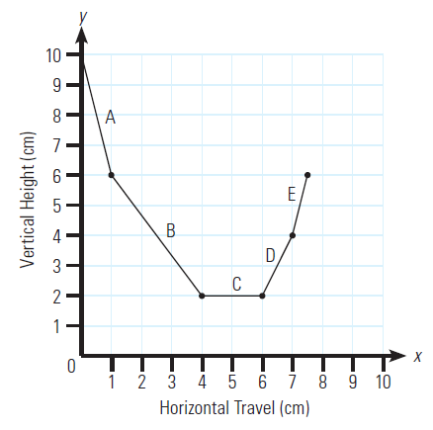

6) Calculate the slope of each segment of the line on the graph to the right.

7) Harry drives a highway truck for a living. On his recent trip, he travelled 350 km in 5 hours.

a) Plot this on the graph paper below.



b) What is Harry’s rate of speed? Hint: find the slope!

c) How far had Harry travelled after 2 hours? Use the graph to **interpolate** this answer. Show your work on the graph.

d) If Harry continues at this speed, how many hours will it take him to drive 630 km? Use the graph to **extrapolate** this answer.

**Ask your teacher for quiz 3**