Pythagoras
Pythagoras' Theorem says that for a right angled triangle, the square of the long side equals the sum of the squares of the other two sides:
x² + y² = 1² (hypotenuse = radius)
But 1² is just 1, so:
x² + y² = 1
equation of the unit circle
Also, since x=cos and y=sin, we get:
x² + y² = 1²
(cos(θ))² + (sin(θ))² = 1
a useful "identity"

Important Angles: 30°, 45° and 60°
You should try to remember sin, cos and tan for the angles 30°, 45° and 60°.
Yes, yes, it is a pain to have to remember things, but it will make life easier when you know them, not just in exams, but other times when you need to do quick estimates, etc.
These are the values you should remember!

How To Remember?

To help you remember, sin goes "1,2,3" :
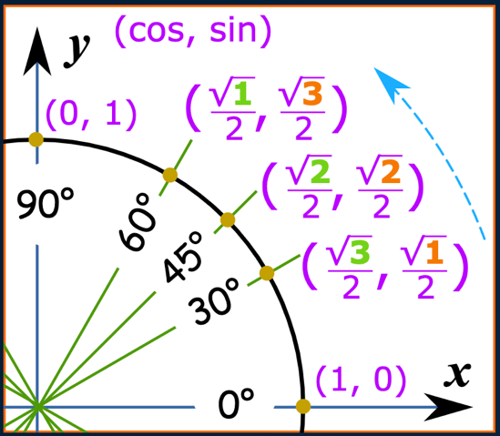
sin(30°) = √1/2 = 1/2 (because √1 = 1)
sin(45°) = √2/2
sin(60°) = √3/2

And cos goes "3,2,1"
cos(30°) = √3/2
cos(45°) = √2/2
cos(60°) = √1/2 = 1/2

Just 3 Numbers
In fact, knowing 3 numbers is enough: 1/2 , √2/2 and √3/2
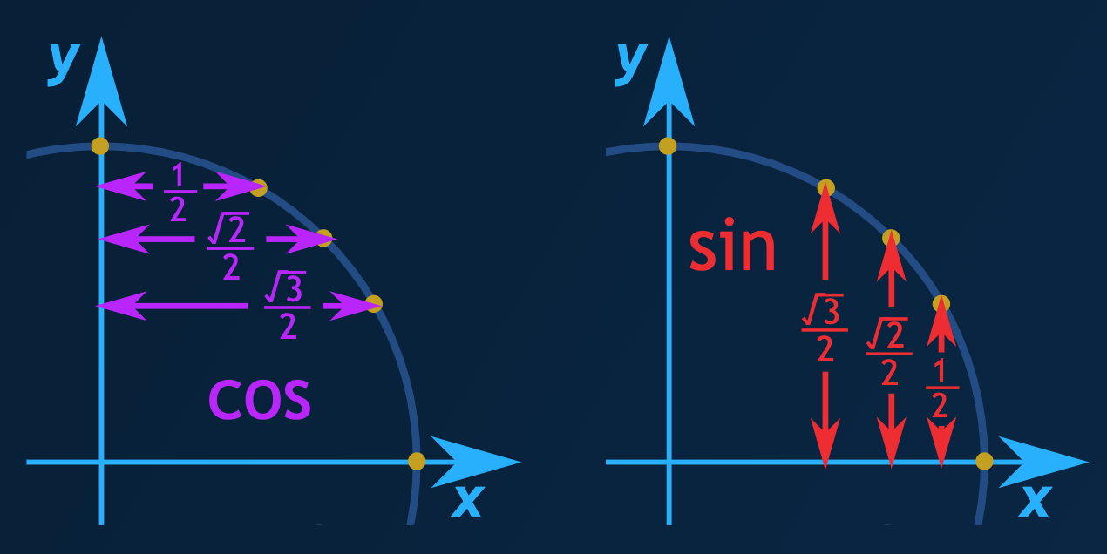
Because they work for both cos and sin:

What about tan?
Well, tan = sin/cos, so we can calculate it like this:
tan(30°) =sin(30°)/cos(30°) = 1/2/√3/2 = 1/√3 = √3/3
tan(45°) =sin(45°)/cos(45°) = √2/2/√2/2 = 1
tan(60°) =sin(60°)cos(60°) = √3/2/1/2 = √3
* Note: writing 1/√3 may cost you marks (see Rational Denominators), so instead use √3/3

Quick Sketch
Another way to help you remember 30° and 60° is to make a quick sketch:
Draw a triangle with side lengths of 2 |  | 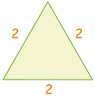
Cut in half. Pythagoras says the new side is √3  1² + (√3)² = 2²  1 + 3 = 4 |  | 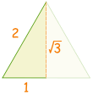
Then use sohcahtoa for sin, cos or tan |  | 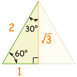

Example: sin(30°)
Sine: sohcahtoa
sine is opposite divided by hypotenuse
sin(30°) = oppositehypotenuse = 12

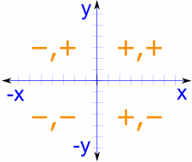

The Whole Circle
For the whole circle we need values in every quadrant, with the correct plus or minus sign as per Cartesian Coordinates:

Note that cos is first and sin is second, so it goes (cos, sin):

